






Create, implement and evaluate strategic product initiatives
D2.TCS.CL5.07
Trainer Guide

Create, implement and evaluate strategic product initiatives
D2.TCS.CL5.07
Trainer Guide





Project Base
William Angliss Institute of TAFE
555 La Trobe Street
Melbourne 3000 Victoria
Telephone: | (03) 9606 2111
Facsimile: | (03) 9670 1330
Acknowledgements
Project Director: | Wayne Crosbie
Project Manager | Jim Irwin
Chief Writer: | Alan Hickman
Subject Writer: | Quentin Derrick
Editor: | Jim Irwin
DTP/Production: | Daniel Chee, Mai Vu, Cindy Curran

The Association of Southeast Asian Nations (ASEAN) was established on 8 August 1967. The Member States of the Association are Brunei Darussalam, Cambodia, Indonesia, Lao PDR, Malaysia, Myanmar, Philippines, Singapore, Thailand and Viet Nam.
The ASEAN Secretariat is based in Jakarta, Indonesia.
General Information on ASEAN appears online at the ASEAN Website: www.asean.org.
All text is produced by William Angliss Institute of TAFE for the ASEAN Project on “Toolbox Development for Tourism Labour Divisions for Travel Agencies and Tour Operations”.
This publication is supported by the Australian Government’s aid program through the ASEAN-Australia Development Cooperation Program Phase II (AADCP II).
Copyright: Association of Southeast Asian Nations (ASEAN) 2015.
All rights reserved.
Disclaimer
Every effort has been made to ensure that this publication is free from errors or omissions. However, you should conduct your own enquiries and seek professional advice before relying on any fact, statement or matter contained in this book. The ASEAN Secretariat and William Angliss Institute of TAFE are not responsible for any injury, loss or damage as a result of material included or omitted from this course. Information in this module is current at the time of publication. Time of publication is indicated in the date stamp at the bottom of each page.
Some images appearing in this resource have been purchased from stock photography suppliers Shutterstock and iStockphoto and other third party copyright owners and as such are non-transferable and non-exclusive. Clip arts, font images and illustrations used are from the Microsoft Office Clip Art and Media Library. Some images have been provided by and are the property of William Angliss Institute.
Additional images have been sourced from Flickr and SXC and are used under Creative Commons licence: http://creativecommons.org/licenses/by/2.0/deed.en
File name: TG_Create_implement__evaluate_strategic_prod_270415





Table of contents
Competency Based Training (CBT) and assessment – An introduction for trainers 1
Competency standard 11
Notes and PowerPoint slides 21
Recommended training equipment 69
Instructions for Trainers for using PowerPoint – Presenter View 71
Appendix – ASEAN acronyms 73

Competency Based Training (CBT) and assessment – An introduction for trainers

Competency
Competency refers to the ability to perform particular tasks and duties to the standard of performance expected in the workplace.
Competency requires the application of specified knowledge, skills and attitudes relevant to effective participation, consistently over time and in the workplace environment.
The essential skills and knowledge are either identified separately or combined.
Knowledge identifies what a person needs to know to perform the work in an informed and effective manner.
Skills describe the application of knowledge to situations where understanding is converted into a workplace outcome.
Attitude describes the founding reasons behind the need for certain knowledge or why skills are performed in a specified manner.
Competency covers all aspects of workplace performance and involves:
- Performing individual tasks
- Managing a range of different tasks
- Responding to contingencies or breakdowns
- Dealing with the responsibilities of the workplace
- Working with others.

Unit of competency
Like with any training qualification or program, a range of subject topics are identified that focus on the ability in a certain work area, responsibility or function.
Each manual focuses on a specific unit of competency that applies in the hospitality workplace.
In this manual a unit of competency is identified as a ‘unit’.
Each unit of competency identifies a discrete workplace requirement and includes:
- Knowledge and skills that underpin competency
- Language, literacy and numeracy
- Occupational safety and health requirements.
Each unit of competency must be adhered to in training and assessment to ensure consistency of outcomes.

Element of competency
An element of competency describes the essential outcomes within a unit of competency.
The elements of competency are the basic building blocks of the unit of competency. They describe in terms of outcomes the significant functions and tasks that make up the competency.
In this manual elements of competency are identified as an ‘element’.

Performance criteria
Performance criteria indicate the standard of performance that is required to demonstrate achievement within an element of competency. The standards reflect identified industry skill needs.
Performance criteria will be made up of certain specified skills, knowledge and attitudes.

Learning
For the purpose of this manual learning incorporates two key activities:
- Training
- Assessment.
Both of these activities will be discussed in detail in this introduction.
Today training and assessment can be delivered in a variety of ways. It may be provided to participants:
- On-the-job – in the workplace
- Off-the-job – at an educational institution or dedicated training environment
- As a combination of these two options.
No longer is it necessary for learners to be absent from the workplace for long periods of time in order to obtain recognised and accredited qualifications.

Learning approaches
This manual will identify two avenues to facilitate learning:
Competency Based Training (CBT)
This is the strategy of developing a participant’s competency.
Educational institutions utilise a range of training strategies to ensure that participants are able to gain the knowledge and skills required for successful:
- Completion of the training program or qualification
- Implementation in the workplace.
The strategies selected should be chosen based on suitability and the learning styles of participants.

Competency Based Assessment (CBA)
This is the strategy of assessing competency of a participant.
Educational institutions utilise a range of assessment strategies to ensure that participants are assessed in a manner that demonstrates validity, fairness, reliability, flexibility and fairness of assessment processes.

Flexibility in learning
It is important to note that flexibility in training and assessment strategies is required to meet the needs of participants who may have learning difficulties. The strategies used will vary, taking into account the needs of individual participants with learning difficulties. However they will be applied in a manner which does not discriminate against the participant or the participant body as a whole.
Catering for participant diversity
Participants have diverse backgrounds, needs and interests. When planning training and assessment activities to cater for individual differences, trainers and assessors should:
- Consider individuals’ experiences, learning styles and interests
- Develop questions and activities that are aimed at different levels of ability
- Modify the expectations for some participants
- Provide opportunities for a variety of forms of participation, such as individual, pair and small group activities
- Assess participants based on individual progress and outcomes.
The diversity among participants also provides a good reason for building up a learning community in which participants support each other’s learning.
Participant centred learning
This involves taking into account structuring training and assessment that:
- Builds on strengths – Training environments need to demonstrate the many positive features of local participants (such as the attribution of academic success to effort, and the social nature of achievement motivation) and of their trainers (such as a strong emphasis on subject disciplines and moral responsibility). These strengths and uniqueness of local participants and trainers should be acknowledged and treasured
- Acknowledges prior knowledge and experience – The learning activities should be planned with participants’ prior knowledge and experience in mind
- Understands learning objectives – Each learning activity should have clear learning objectives and participants should be informed of them at the outset. Trainers should also be clear about the purpose of assignments and explain their significance to participants
- Teaches for understanding – The pedagogies chosen should aim at enabling participants to act and think flexibly with what they know
- Teaches for independent learning – Generic skills and reflection should be nurtured through learning activities in appropriate contexts of the curriculum. Participants should be encouraged to take responsibility for their own learning
- Enhances motivation – Learning is most effective when participants are motivated. Various strategies should be used to arouse the interest of participants
- Makes effective use of resources – A variety of teaching resources can be employed as tools for learning
- Maximises engagement – In conducting learning activities, it is important for the minds of participants to be actively engaged
- Aligns assessment with learning and teaching – Feedback and assessment should be an integral part of learning and teaching
- Caters for learner diversity – Trainers should be aware that participants have different characteristics and strengths and try to nurture these rather than impose a standard set of expectations.
Active learning
The goal of nurturing independent learning in participants does not imply that they always have to work in isolation or solely in a classroom. On the contrary, the construction of knowledge in tourism and hospitality studies can often best be carried out in collaboration with others in the field. Sharing experiences, insights and views on issues of common concern, and working together to collect information through conducting investigative studies in the field (active learning) can contribute a lot to their eventual success.
Active learning has an important part to play in fostering a sense of community in the class. First, to operate successfully, a learning community requires an ethos of acceptance and a sense of trust among participants, and between them and their trainers. Trainers can help to foster acceptance and trust through encouragement and personal example, and by allowing participants to take risks as they explore and articulate their views, however immature these may appear to be. Participants also come to realise that their classmates (and their trainers) are partners in learning and solving.
Trainers can also encourage cooperative learning by designing appropriate group learning tasks, which include, for example, collecting background information, conducting small-scale surveys, or producing media presentations on certain issues and themes. Participants need to be reminded that, while they should work towards successful completion of the field tasks, developing positive peer relationships in the process is an important objective of all group work.

Competency Based Training (CBT)
Principle of Competency Based Training
Competency based training is aimed at developing the knowledge, skills and attitudes of participants, through a variety of training tools.
Training strategies
The aims of this curriculum are to enable participants to:
- Undertake a variety of subject courses that are relevant to industry in the current environment
- Learn current industry skills, information and trends relevant to industry
- Learn through a range of practical and theoretical approaches
- Be able to identify, explore and solve issues in a productive manner
- Be able to become confident, equipped and flexible managers of the future
- Be ‘job ready’ and a valuable employee in the industry upon graduation of any qualification level.
To ensure participants are able to gain the knowledge and skills required to meet competency in each unit of competency in the qualification, a range of training delivery modes are used.
Types of training
In choosing learning and teaching strategies, trainers should take into account the practical, complex and multi-disciplinary nature of the subject area, as well as their participant’s prior knowledge, learning styles and abilities.
Training outcomes can be attained by utilising one or more delivery methods:
Lecture/tutorial
This is a common method of training involving transfer of information from the trainer to the participants. It is an effective approach to introduce new concepts or information to the learners and also to build upon the existing knowledge. The listener is expected to reflect on the subject and seek clarifications on the doubts.
Demonstration
Demonstration is a very effective training method that involves a trainer showing a participant how to perform a task or activity. Through a visual demonstration, trainers may also explain reasoning behind certain actions or provide supplementary information to help facilitate understanding.
Group discussions
Brainstorming in which all the members in a group express their ideas, views and opinions on a given topic. It is a free flow and exchange of knowledge among the participants and the trainer. The discussion is carried out by the group on the basis of their own experience, perceptions and values. This will facilitate acquiring new knowledge. When everybody is expected to participate in the group discussion, even the introverted persons will also get stimulated and try to articulate their feelings.
The ideas that emerge in the discussions should be noted down and presentations are to be made by the groups. Sometimes consensus needs to be arrived at on a given topic. Group discussions are to be held under the moderation of a leader guided by the trainer. Group discussion technique triggers thinking process, encourages interactions and enhances communication skills.
Role play
This is a common and very effective method of bringing into the classroom real life situations, which may not otherwise be possible. Participants are made to enact a particular role so as to give a real feel of the roles they may be called upon to play. This enables participants to understand the behaviour of others as well as their own emotions and feelings. The instructor must brief the role players on what is expected of them. The role player may either be given a ready-made script, which they can memorize and enact, or they may be required to develop their own scripts around a given situation. This technique is extremely useful in understanding creative selling techniques and human relations. It can be entertaining and energizing and it helps the reserved and less literate to express their feelings.

Simulation games
When trainees need to become aware of something that they have not been conscious of, simulations can be a useful mechanism. Simulation games are a method based on "here and now" experience shared by all the participants. The games focus on the participation of the trainees and their willingness to share their ideas with others. A "near real life" situation is created providing an opportunity to which they apply themselves by adopting certain behaviour. They then experience the impact of their behaviour on the situation. It is carried out to generate responses and reactions based on the real feelings of the participants, which are subsequently analysed by the trainer.
While use of simulation games can result in very effective learning, it needs considerable trainer competence to analyse the situations.
Individual /group exercises
Exercises are often introduced to find out how much the participant has assimilated. This method involves imparting instructions to participants on a particular subject through use of written exercises. In the group exercises, the entire class is divided into small groups, and members are asked to collaborate to arrive at a consensus or solution to a problem.
Case study
This is a training method that enables the trainer and the participant to experience a real life situation. It may be on account of events in the past or situations in the present, in which there may be one or more problems to be solved and decisions to be taken. The basic objective of a case study is to help participants diagnose, analyse and/or solve a particular problem and to make them internalize the critical inputs delivered in the training. Questions are generally given at the end of the case study to direct the participants and to stimulate their thinking towards possible solutions. Studies may be presented in written or verbal form.
Field visit
This involves a carefully planned visit or tour to a place of learning or interest. The idea is to give first-hand knowledge by personal observation of field situations, and to relate theory with practice. The emphasis is on observing, exploring, asking questions and understanding. The trainer should remember to brief the participants about what they should observe and about the customs and norms that need to be respected.
Group presentation
The participants are asked to work in groups and produce the results and findings of their group work to the members of another sub-group. By this method participants get a good picture of each other's views and perceptions on the topic and they are able to compare them with their own point of view. The pooling and sharing of findings enriches the discussion and learning process.
Practice sessions
This method is of paramount importance for skills training. Participants are provided with an opportunity to practice in a controlled situation what they have learnt. It could be real life or through a make-believe situation.

Games
This is a group process and includes those methods that involve usually fun-based activity, aimed at conveying feelings and experiences, which are everyday in nature, and applying them within the game being played. A game has set rules and regulations, and may or may not include a competitive element. After the game is played, it is essential that the participants be debriefed and their lessons and experiences consolidated by the trainer.
Research
Trainers may require learners to undertake research activities, including online research, to gather information or further understanding about a specific subject area.

Competency Based Assessment (CBA)
Principle of Competency Based Assessment
Competency based assessment is aimed at compiling a list of evidence that shows that a person is competent in a particular unit of competency.
Competencies are gained through a multitude of ways including:
- Training and development programs
- Formal education
- Life experience
- Apprenticeships
- On-the-job experience
- Self-help programs.
All of these together contribute to job competence in a person. Ultimately, assessors and participants work together, through the ‘collection of evidence’ in determining overall competence.
This evidence can be collected:
- Using different formats
- Using different people
- Collected over a period of time.
The assessor who is ideally someone with considerable experience in the area being assessed, reviews the evidence and verifies the person as being competent or not.
Flexibility in assessment
Whilst allocated assessment tools have been identified for this subject, all attempts are made to determine competency and suitable alternate assessment tools may be used, according to the requirements of the participant.
The assessment needs to be equitable for all participants, taking into account their cultural and linguistic needs.
Competency must be proven regardless of:
- Language
- Delivery Method
- Assessment Method.
Assessment objectives
The assessment tools used for subjects are designed to determine competency against the ‘elements of competency’ and their associated ‘performance criteria’.
The assessment tools are used to identify sufficient:
- Knowledge, including underpinning knowledge
- Skills
- Attitudes
Assessment tools are activities that trainees are required to undertake to prove participant competency in this subject.
All assessments must be completed satisfactorily for participants to obtain competence in this subject. There are no exceptions to this requirement, however, it is possible that in some cases several assessment items may be combined and assessed together.
Types of assessment
Allocated Assessment Tools
There are a number of assessment tools that are used to determine competency in this subject:
- Work projects
- Written questions
- Oral questions
- Third Party Report
- Observation Checklist.
Instructions on how assessors should conduct these assessment methods are explained in the Assessment Manuals.
Alternative assessment tools
Whilst this subject has identified assessment tools, as indicated above, this does not restrict the assessor from using different assessment methods to measure the competency of a participant.
Evidence is simply proof that the assessor gathers to show participants can actually do what they are required to do.
Whilst there is a distinct requirement for participants to demonstrate competency, there are many and diverse sources of evidence available to the assessor.
Ongoing performance at work, as verified by a supervisor or physical evidence, can count towards assessment. Additionally, the assessor can talk to customers or work colleagues to gather evidence about performance.
A range of assessment methods to assess competency include:
- Practical demonstrations
- Practical demonstrations in simulated work conditions
- Problem solving
- Portfolios of evidence
- Critical incident reports
- Journals
- Oral presentations
- Interviews
- Videos
- Visuals: slides, audio tapes
- Case studies
- Log books
- Projects
- Role plays
- Group projects
- Group discussions
- Examinations.
Recognition of Prior Learning
Recognition of Prior Learning is the process that gives current industry professionals who do not have a formal qualification, the opportunity to benchmark their extensive skills and experience against the standards set out in each unit of competency/subject.
Also known as a Skills Recognition Audit (SRA), this process is a learning and assessment pathway which encompasses:
- Recognition of Current Competencies (RCC)
- Skills auditing
- Gap analysis and training
- Credit transfer.
Assessing competency
As mentioned, assessment is the process of identifying a participant’s current knowledge, skills and attitudes sets against all elements of competency within a unit of competency. Traditionally in education, grades or marks were given to participants, dependent on how many questions the participant successfully answered in an assessment tool.
Competency based assessment does not award grades, but simply identifies if the participant has the knowledge, skills and attitudes to undertake the required task to the specified standard.
Therefore, when assessing competency, an assessor has two possible results that can be awarded:
- Pass Competent (PC)
- Not Yet Competent (NYC).
Pass Competent (PC)
If the participant is able to successfully answer or demonstrate what is required, to the expected standards of the performance criteria, they will be deemed as ‘Pass Competent’ (PC).
The assessor will award a ‘Pass Competent’ (PC) if they feel the participant has the necessary knowledge, skills and attitudes in all assessment tasks for a unit.
Not Yet Competent’ (NYC)
If the participant is unable to answer or demonstrate competency to the desired standard, they will be deemed to be ‘Not Yet Competent’ (NYC).
This does not mean the participant will need to complete all the assessment tasks again. The focus will be on the specific assessment tasks that were not performed to the expected standards.
The participant may be required to:
a) Undertake further training or instruction
b) Undertake the assessment task again until they are deemed to be ‘Pass Competent’.

Competency standard
UNIT TITLE: CREATE, IMPLEMENT AND EVALUATE STRATEGIC PRODUCT INITIATIVES |  |  |  | NOMINAL HOURS: 70
UNIT NUMBER: D2.TCS.CL5.07
UNIT DESCRIPTOR: This unit deals with skills and knowledge required to identify and respond to organisational needs to develop strategic product initiatives.
ELEMENTS AND PERFORMANCE CRITERIA | UNIT VARIABLE AND ASSESSMENT GUIDE
Element 1: Create strategic product initiatives  - Identify the context for product development  - Undertake market research on identified opportunities and identified target markets  - Determine product life cycle issues that apply to identified opportunities and products  - Determine financial issues that relate to the development of product initiatives  - Research product development opportunities that align with the context that applies  - Develop product development plans reflecting research information and business objectives  - Produce the identified product or service initiative  Element 2: Implement strategic product initiatives  - Trial the initiative in accordance with established plans  - Revise the initiative as required on the basis of operational matters and customer feedback | Unit Variables  The Unit Variables provide advice to interpret the scope and context of this unit of competence, allowing for differences between enterprises and workplaces. It relates to the unit as a whole and facilitates holistic assessment.  This unit applies to the management of strategic product development, introduction and evaluation within an organisation in the labour divisions of the hotel and travel industries and may include:  - Travel Agencies  - Tour Operation  Identify the context may be related to:  - Describing the current trading and competitive environment being faced by the organisation and the industry  - Identifying products and services being offered by competitors  - Quantifying and describing changes to the level of competition being experienced, including increases and reductions in competition  - Considering technological changes and initiatives that may have presented new opportunities  - Quantifying and evaluating sales and profits experienced by the organisation  - Identifying existing and emerging industry trends, customer expectations and requirements  - Assessing available resources to support the development of initiatives, including funding, human resources and physical resources
- Monitor the introduction and implementation of the initiative  - Apply change management skills to facilitate the introduction and establishment of the initiative  - Promote the initiative to customers  Element 3: Evaluate strategic product initiatives  - Record statistical data to enable evaluation against Key Performance Indicators to occur  - Solicit and record feedback from stakeholders  - Compare projected outcomes against actual outcomes  - Determine and implement changes, if any, that need to be made to maintain or revise the initiative | - Identifying timing considerations, including seasonal factors, immediacy needs, peak and low tourist/travel seasons  - Noting existing legislative requirements, including changes to legislation that may have revealed new opportunities  - Determining the objectives contained in existing and proposed business and strategic plans of the organisation  - Reviewing key organisational capability statements of the business  - Identifying options for initiatives that arise on the basis of initial contextual evaluation  - Undertaking a situational analysis identifying the Strengths and Weaknesses of the organisation and existing Opportunities and Threats (SWOT analysis).  Product development may include:  - Tour development  - Package programs  - New customer service features  - Building of new facilities  - Special interest programs  - Guest activities and shows  - Exhibits  - Integration of new technology into existing products and services  - Amendments to existing products and services  - Joint venture initiatives with partners  - Removal of products and services from an existing product and service list.  Undertake market research should include:  - Identifying objectives for market research  - Determining market research techniques to be applied
- Selecting targets for primary market research
- Developing and trialling primary market research tools
- Applying the prepared market research tools to obtain primary data in accordance with previously established procedures
- Examining and analysing trends and relevant secondary information, including quantitative and qualitative data
- Analyse and evaluate the results of the market research
- Identify and describe the potential opportunities that have been identified by the market research.
Product life cycle issues should relate to:
- Determining the stage within the product life cycle that current products and services are at, including consideration of the recognised phases of Introduction, Growth, Maturation, Saturation and Decline
- Considering the products and services offered by competitors in terms of the product life cycle.
Financial issues may include:
- Availability of funding, including the potential to borrow money
- Quantifying expected development and implementation costs of initiatives
- Determining cash flow situation of the business
- Sourcing joint venture partners and identifying their level of financial contribution to and their expectations of revenue from, the initiative
- Seeking financial support from industry bodies and government authorities, including identification of requirements that may apply to grants or other financial incentives
- Considering taxation implications of implementing the initiative.
Research product development opportunities may include:
- Visiting organisations of interest, including suppliers, competitors and other relevant, local, domestic and international operators
- Seeking input from relevant stakeholders, including colleagues, local communities and special interest groups
- Seeking input from authorities and industry peak bodies
- Providing resources to enable research to be effectively undertaken, including financial, resources, physical resources and time
- Conducting desk-top cost-benefit analysis of potentially viable options
- Performing internal gap analysis to identify requirements that need to be acquired to support the development process
- Undertaking small scale feasibility studies
- Undertaking market research to determine potential acceptability and up-take of selected product and service initiatives
- Generating, analysing and evaluating innovative ideas that arise.
Develop product development plans may include:
- Evaluating strategy development models that exist
- Selecting a strategy development model appropriate for the initiative that has been chosen and applicable to the associated trading and competitive position of the organisation
- Integrating product development plans into existing business and strategic plans, including revising existing plans to accommodate changes in direction and/or objectives
- Developing a suite of plans that align with the accepted requirements of plans to be SMART (Specific; Measurable; Accurate; Realistic and Relevant; Track-able and Time-related)
- Developing policies and procedures to guide and govern the implementation of the initiative
- Allocating tasks, resources and responsibilities to enable the identified product and service initiatives to be achieved
- Identifying quality standards that will apply to the initiative
- Developing monitoring and evaluation criteria against which to assess the progress and success of the initiative, including development of Key Performance Indicators (KPIs), where appropriate.
Trial the initiative may include:
- Applying gradual and scheduled introduction of the initiative, or specified aspects of the initiative, into delivery of existing products and services
- Conducting small scale introduction of the initiative to targeted tours and/or customer groups.
Monitor the introduction and implementation may include:
- Seeking and analysing feedback on the trial from customers and partners
- Personal observation
- Monitoring and recording unanticipated operational issues that arise as a result of the introduction of the initiative
- Analysing statistical data gathered as a result of the initiative, including costs, revenue, visitor numbers/traffic patterns, bookings, enquiries and responses
- Determining whether or not to continue with the initiative, including decisions relating to the need to proceed and/or the need to amend the initiative.
Apply change management skills should include:
- Communicating the initiative to staff and relevant stakeholders, including explanation of plans to support implementation
- Explaining the need for and benefits of, the initiative
- Defining parameters and key performance indicators
- Advising staff of changes to standard operating procedures required to integrate and/or introduce the initiative
- Providing training, including opportunities for practice relating to the introduction of the initiative under simulated and actual conditions
- Assuring staff of organisational support during the introductory phase of the initiative, including identification of the nature of the support available and the duration that such support is available
- Assisting staff with revisions to individual workplace goals, priorities and time management caused by the initiative
- Revising team structure and membership, where appropriate
- Acknowledging and rewarding compliance with changes, including celebrating and sharing workplace successes
- Providing counselling and discipline for non-compliance where previous attempts at assistance have failed to achieve compliance with requirements
- Overcoming resistance to change and cementing acceptable change into standard operating procedures.
Promote the initiative may include:
- Verbally notifying customers and potential customers in relation to the initiative, including explanation of the benefits that the initiative involves
- Including the initiative in mass media advertising
- Incorporating the initiative into brochures and other relevant marketing materials, including in-house and external materials
- Conducting media events to launch the initiative.
Statistical data may include:
- Costs, including costs related to time spent on development, training, acquisition of resources and lost opportunity costs, where applicable
- Revenue
- Profit, including actual profit and return on investment
- Visitor numbers/traffic patterns
- Number of bookings
- Number of enquiries received
- Number of responses generated.
Stakeholders may include:
- Staff
- Customers, including existing and new customers with an emphasis on those groups targeted by the introduction of the initiative
- Joint venture partners.
Compare projected outcomes against actual outcomes must include:
- Using the established KPIs as the basis for comparison
- Factoring in any unintended and/or unanticipated negative or positive results.
Assessment Guide
The following skills and knowledge must be assessed as part of this unit:
- Enterprise policies and procedures in regard to product development, promotion, ethical standards and the positioning of the organisation in the competitive business environment
- Principles of market research and data analysis
- Ability to use verbal and written communication skills, leadership skills, negotiation skills and creative thinking techniques
- Ability to counsel and coach staff
- Ability to use planning and project management skills
- Knowledge of legal issues and implications that apply to the development and introduction of initiatives that have been identified
- Knowledge of insurance requirements relating to the implementation of initiatives that have been identified
- Knowledge of occupational health, safety and welfare issues, if any, that may be involved in the development and implementation of the identified initiative
- General market knowledge relating to products and services being offered and the activities of marketplace competitors.
Linkages To Other Units
- Access and retrieve computer-based data
- Develop and update local knowledge
- Develop a marketing strategy and coordinate sales activities
- Develop and implement a business plan
- Develop new products and services
- Gather and present product information
- Manage and implement small projects
- Plan and establish systems and procedures
- Plan, manage and conduct meetings
- Prepare business documents
- Develop and implement operational policies
- Manage legal requirements for business compliance
- Monitor staff performance
- Provide professional support to business colleagues
- Recruit and select staff
- Develop and update tourism industry knowledge
- Promote products and services to customers
- Source and package tourism products and services
- Develop and implement operational plans
- Co-ordinate production of brochures and marketing materials
- Develop, manage and evaluate local marketing strategies
- Promote tourism products and services
- Source and present information
- Interpret financial statements and reports
- Lead and manage a development team
- Monitor workplace operations
- Develop/monitor ecologically sustainable tourism operations
- Plan, trial and implement minimal impact operations
- Develop and co-ordinate appropriate cultural tourism activity.
Critical Aspects of Assessment
Evidence of the following is essential:
- Understanding of host enterprise policies and procedures in regard to product development, promotion, ethical standards and the positioning of the organisation in the competitive business environment
- Demonstrated ability to create, implement and evaluate within a specified timeframe, an effective and viable strategic product and/or service initiative for a nominated industry context within designated resource limitations.
Context of Assessment
Assessment must ensure:
- Actual or simulated workplace application of planning, implementation and evaluation activities relating to the product initiative.
Resource Implications
Training and assessment must include a real industry context, real products and services, and real or simulated customers.
Assessment Methods
The following methods may be used to assess competency for this unit:
- Observation of practical candidate performance
- Analysis of documentation produced, including research data, plans, feedback records and revisions to plans
- Analysis of statistical and qualitative data recorded
- Interviews with customers who were the recipients of the introduction and/or implementation of the initiative
- Oral and written questions
- Third party reports completed by a supervisor
- Project and assignment work.
Key Competencies in this Unit
Level 1 = competence to undertake tasks effectively
Level 2 = competence to manage tasks
Level 3 = competence to use concepts for evaluating
 | Key Competencies | Level | Examples
 | Collecting, organising and analysing information | 3 | Capturing and analysing primary and secondary market research data
 | Communicating ideas and information | 2 | Proving change management support to staff
 | Planning and organising activities | 3 | Developing criteria against which the effectiveness of the initiative can be judged
 | Working with others and in teams | 2 | Explaining the initiative to staff and customers
 | Using mathematical ideas and techniques | 3 | Determining the outcomes of the initiative using comparison of projected results against actual results
 | Solving problems | 2 | Amending the proposed initiative on the basis of operational matters and/or feedback from staff or customers
 | Using technology | 2 | Using project planning and project management software

Notes and PowerPoint slides
Slide
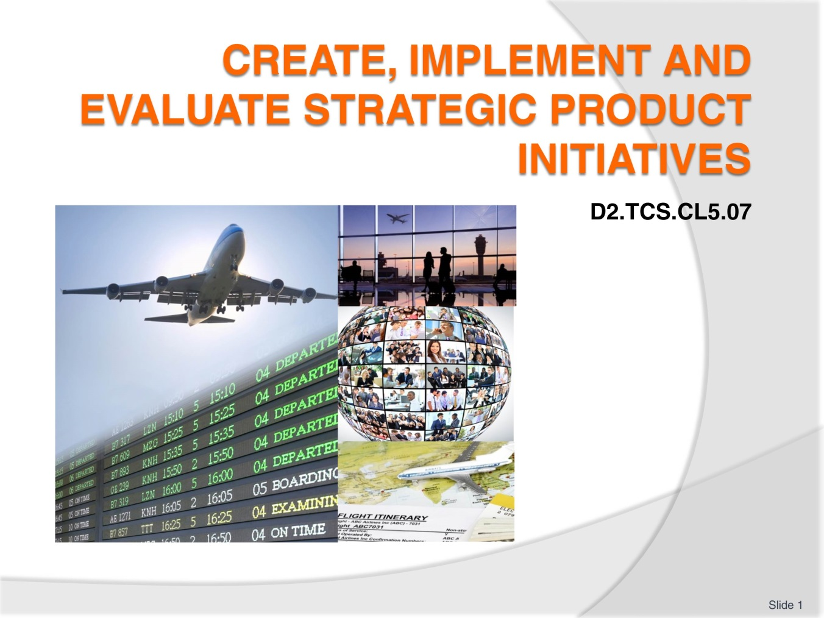
Slide No | Trainer Notes
 | Trainer welcomes students to class.

Slide
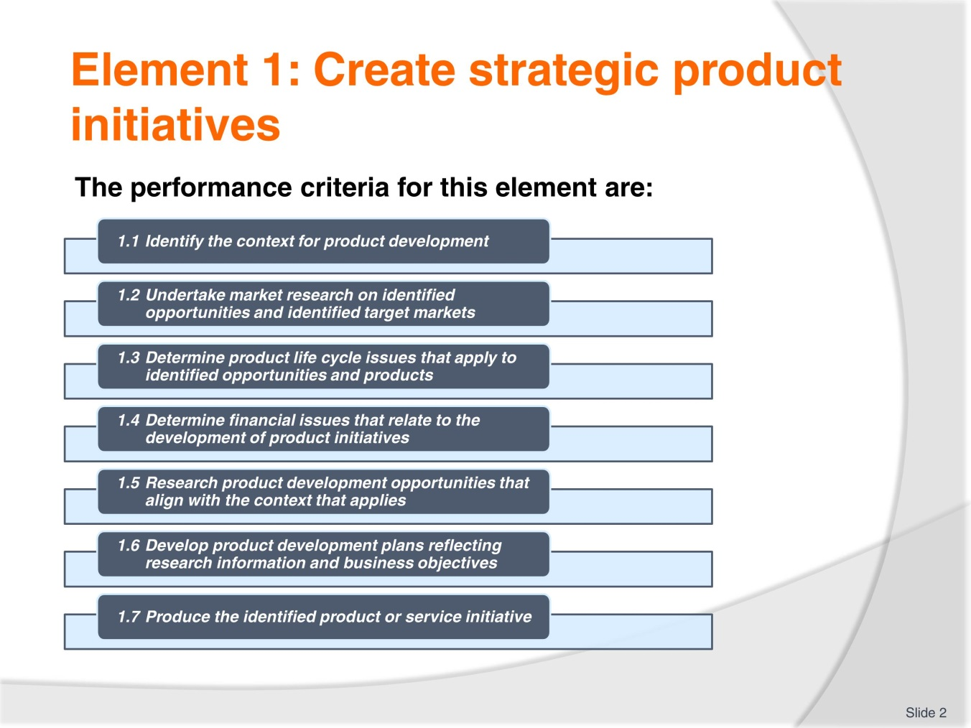
Slide No | Trainer Notes
 | Trainer should go through the assessment and expectations of the course. Trainer should draw trainees’ attention to work projects and due dates.

Slide
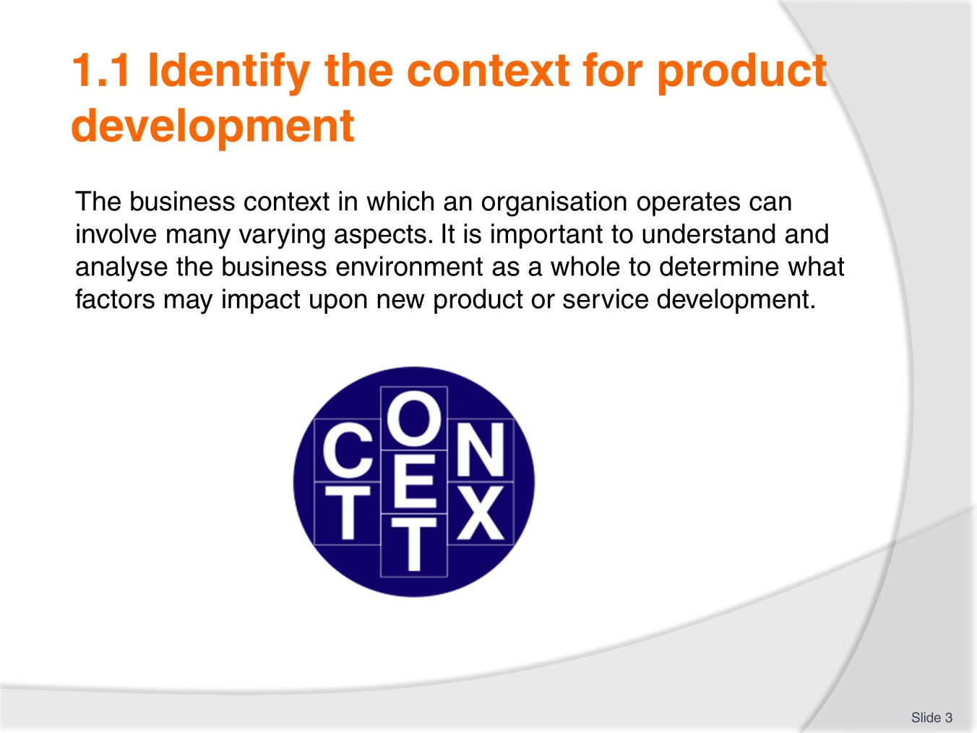
Slide No | Trainer Notes
Class Activity – Discussion
Trainer to provide examples

Slide
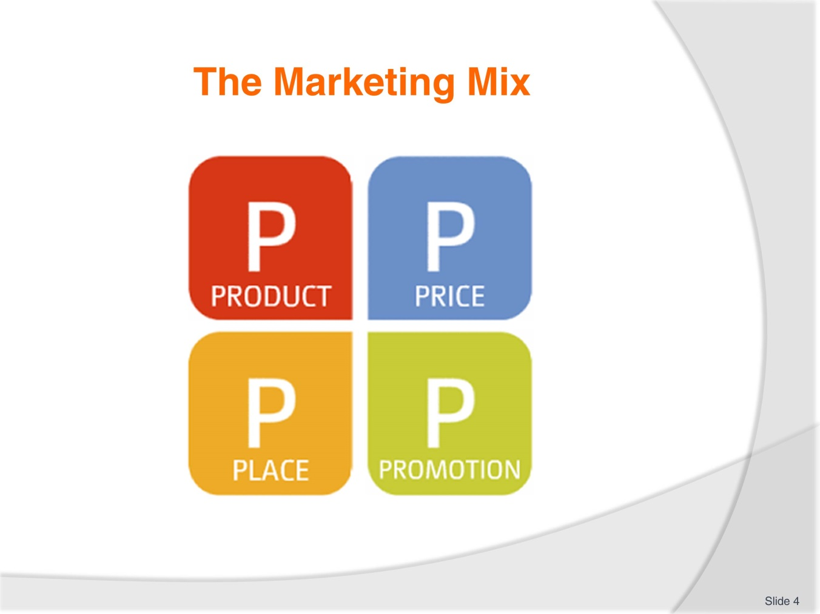
Slide No | Trainer Notes
Trainer to explain the marketing mix and also the external environment surrounding the marketing mix.
The Four P’s
Price
The price aspect of the marketing mix refers to the value of an organisation’s products and service. Some of the factors that influence price may be the cost to make or deliver the product or service, discounting strategies, and positioning in relation to competitor pricing.
Product
These are the goods and services that an organisation offers to its customers or consumers. Products and services have both tangible and intangible aspects and services are often intangible in that you can’t see, touch or feel the service, only the effect of it or impression.
Place
This refers to how and where the product or services are being delivered to customers. The place where product or service delivery occurs has a significant impact on deciding to develop or deliver a service. Place is sometimes referred to as distribution and includes location, facilities, and whether other intermediary partners are needed.
Promotion
Promotion relates to how customers are informed about the product or service and includes advertising, sales promotion, public relations and personal sales.
These four marketing variables operate within an external environment which includes competitive, political and legal, technological, social, and economic factors. All of these components influence the type of products and services that your organisation will develop.

Slide
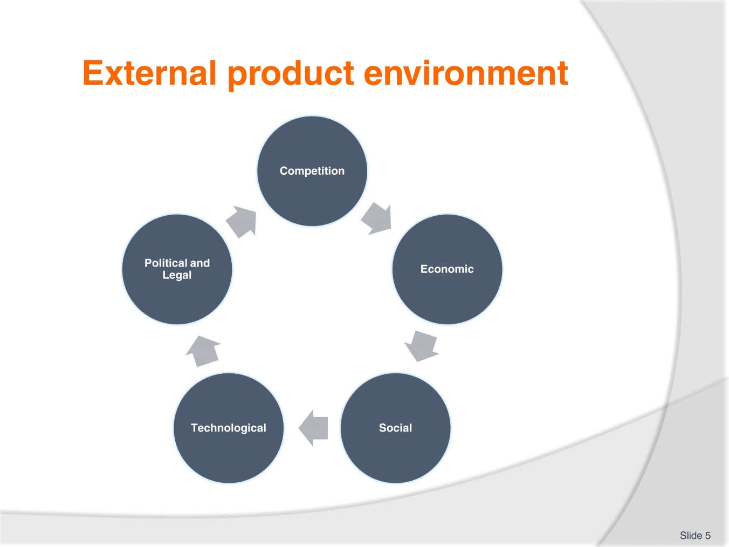
Slide No | Trainer Notes
Trainer explains each external factor and provides an example of each area. Trainees can draw from the TM.
Activity: Participants could think of a product within their organisation and outline an example of each component of the marketing mix and how it may affect the product/service.

Slide
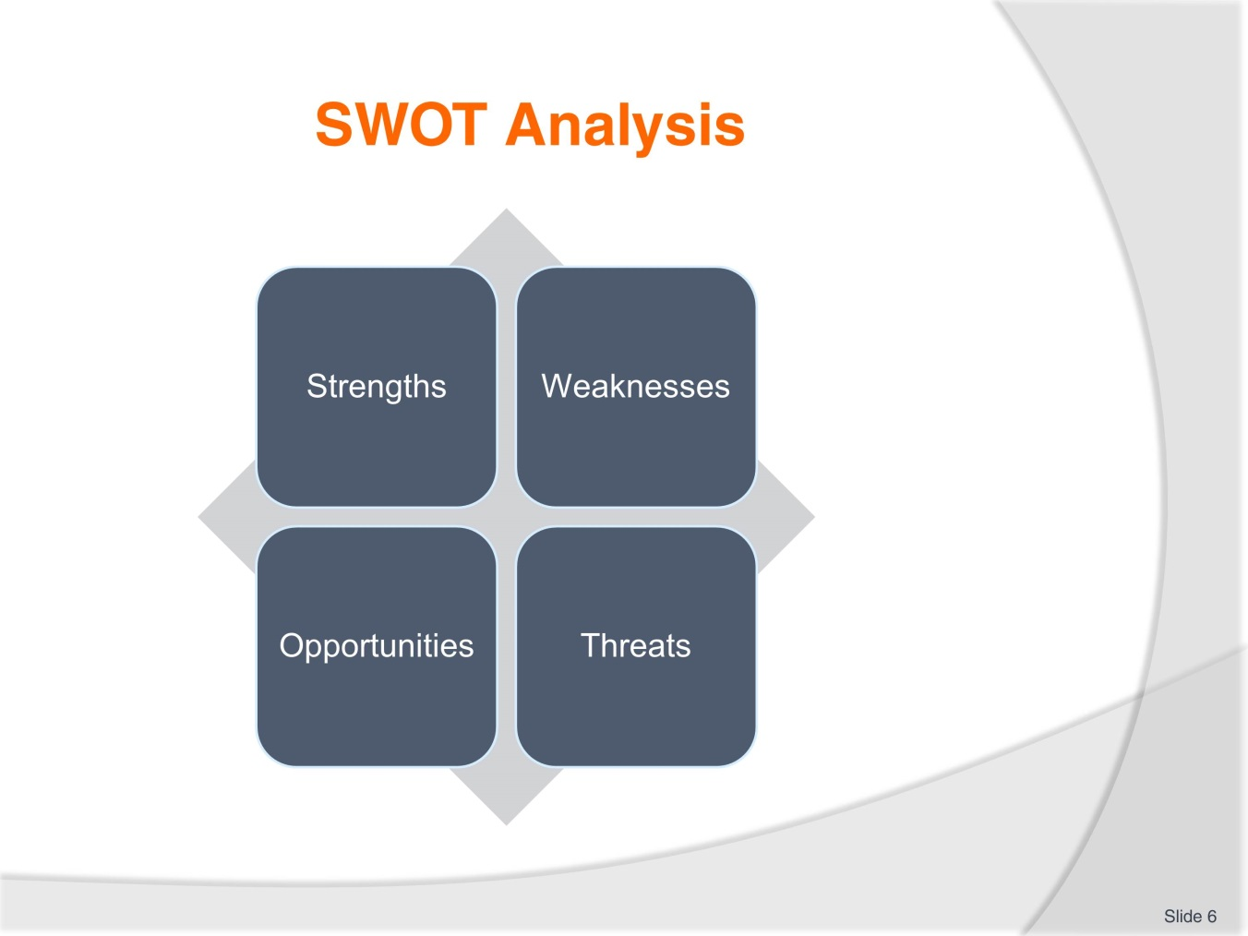
Slide No | Trainer Notes
Trainer explains the four components of the SWOT Analysis. Trainer asks students to explain why a SWOT analysis is important to conduct.
Trainees read through the TM and identify examples of each component.
Activity: Trainees think about their organization and identify examples of each area of the matrix within their organization. Which examples are internal and external?

Slide
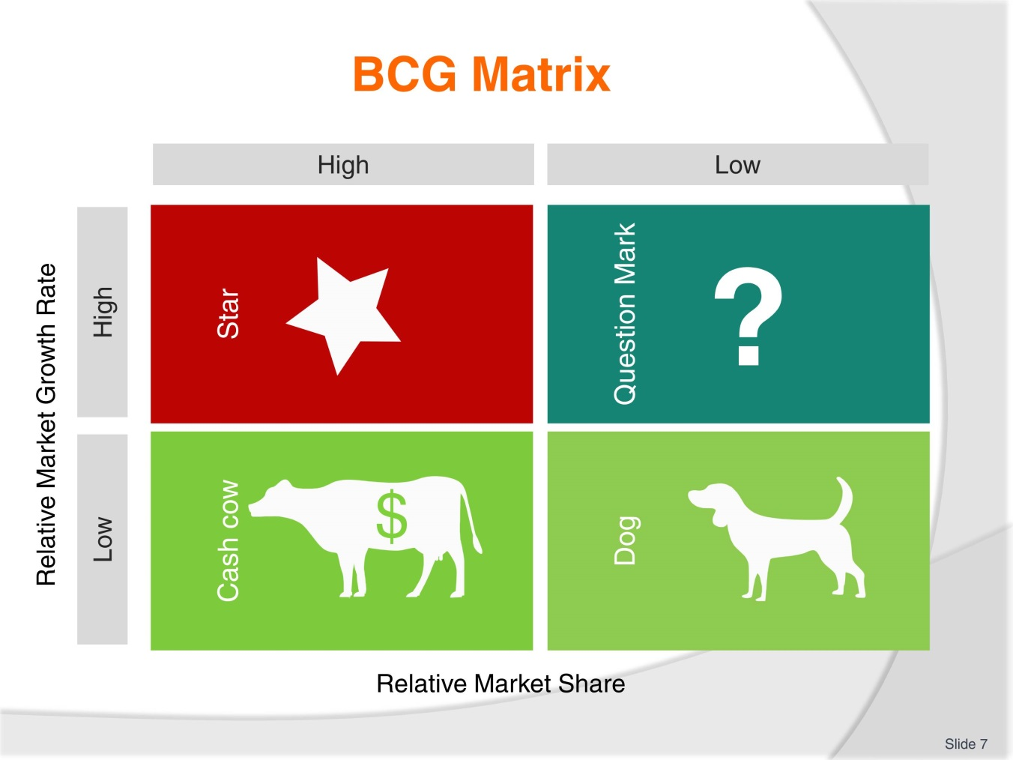
Slide No | Trainer Notes
Trainer explains the Boston Consulting Group Matrix:
Another matrix that is used to determine what products and services are successful or not is the Boston Consulting Group Matrix. This is similar to a SWOT analysis but identifies business performance areas to improve, cease or develop. Stars are the products, services or business lines that are performing well and they should be promoted and encouraged to grow. Cash cows are the services and products that consistently produce good results and are often the core business. The revenue that they produce is used to fund Stars and potential question marks. Question marks are the products and services that an organisation is not sure about. It is important to analyse why these business lines are not performing as well as expected and a decision needs to be made whether to continue or cease these products and services. Dogs are under-performing products and services and they should be stopped.

Slide
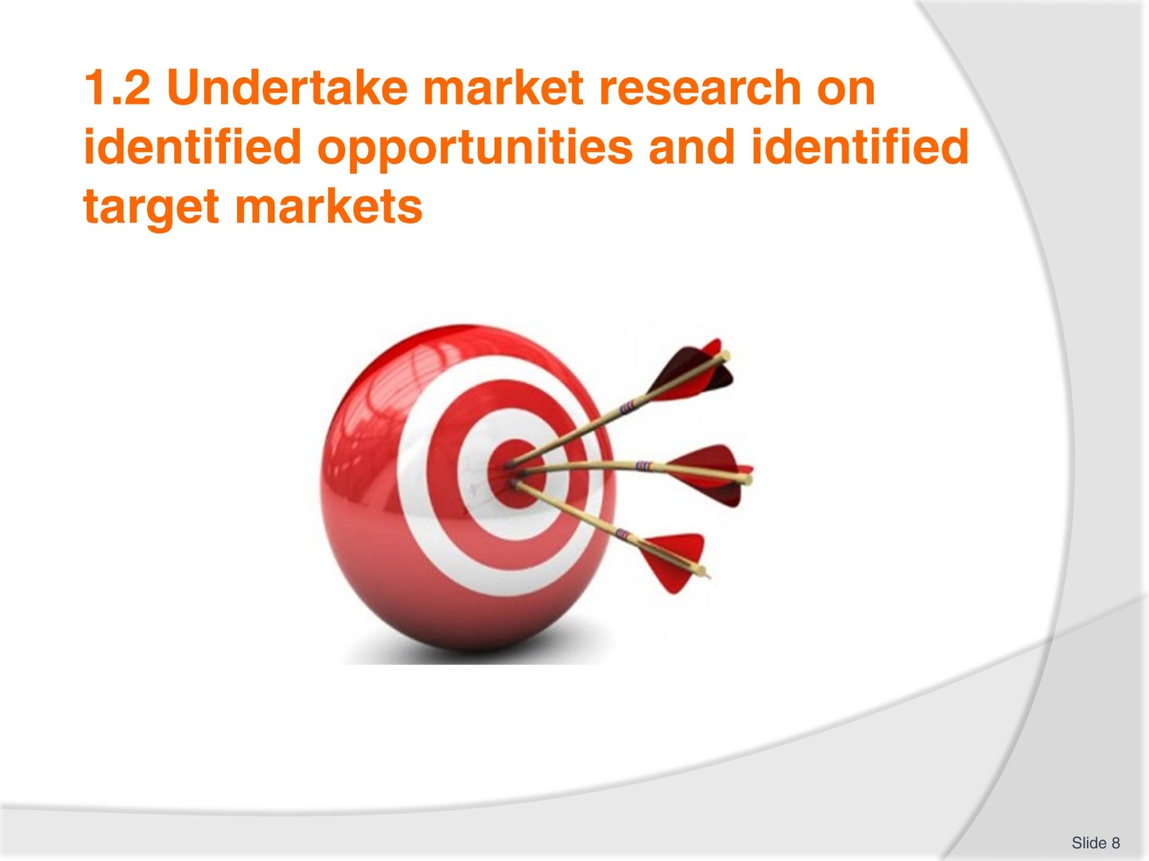
Slide No | Trainer Notes
Trainer explains the importance of identifying targets and objectives for marketing activities.
Objectives should also follow the SMART rule in that they should be:
- Specific, Measurable, Achievable, Realistic, Time-based
- In developing market research objectives it may be helpful to ask:
- What is the organisation’s overall strategy?
- How does the organisation work to achieve these goals?
- What resources are available or needed to undertake the market research?
- Are the objectives achievable and realistic?
- What are the timeframes for market research activities?
- What finances or budget are required?

Slide

Slide No | Trainer Notes
Trainer explains the need for collecting relevant data that could assist with new product or service development. Relevant data should be collected from various sources and may include Primary and Secondary data. . Data can be classified as primary and secondary where primary data is collected for a specific designated reason and secondary data is previously gathered information that may be relevant and useful for another purpose. Trainer highlights the challenges associated with collecting primary data.
Activity: Trainees provide examples of marketing data that is gathered within their organisations and determine if it is primary or secondary data.

Slide
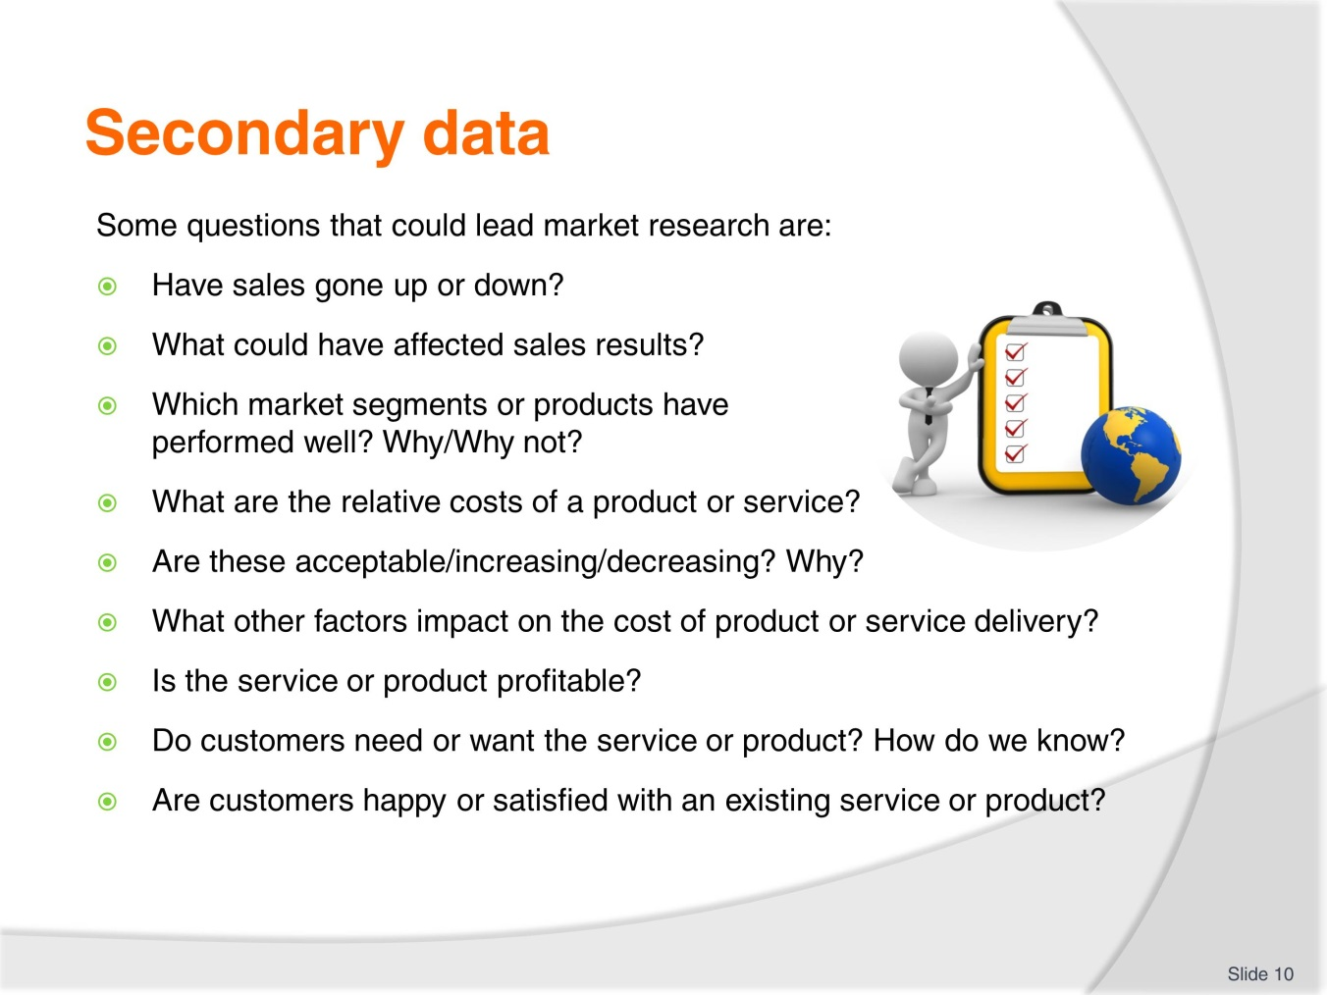
Slide No | Trainer Notes
Trainer asks “How does your organization answer these questions?”
Trainees provide some possible answers and examples from their workplace.

Slide

Slide No | Trainer Notes
 | Trainer explains the difference between the two data collection techniques. Data collection techniques could draw upon quantitative or qualitative data. Quantitative data is numerical, statistically reliable and applicable to a broader context. Qualitative data is non-numerical, in-depth and directional in that it can show where to go with product or service development. Once the research methods have been chosen, the data must be gathered. Secondary sources of data should be collected first and then a decision needs to be made as to whether primary data is also needed.

Slide
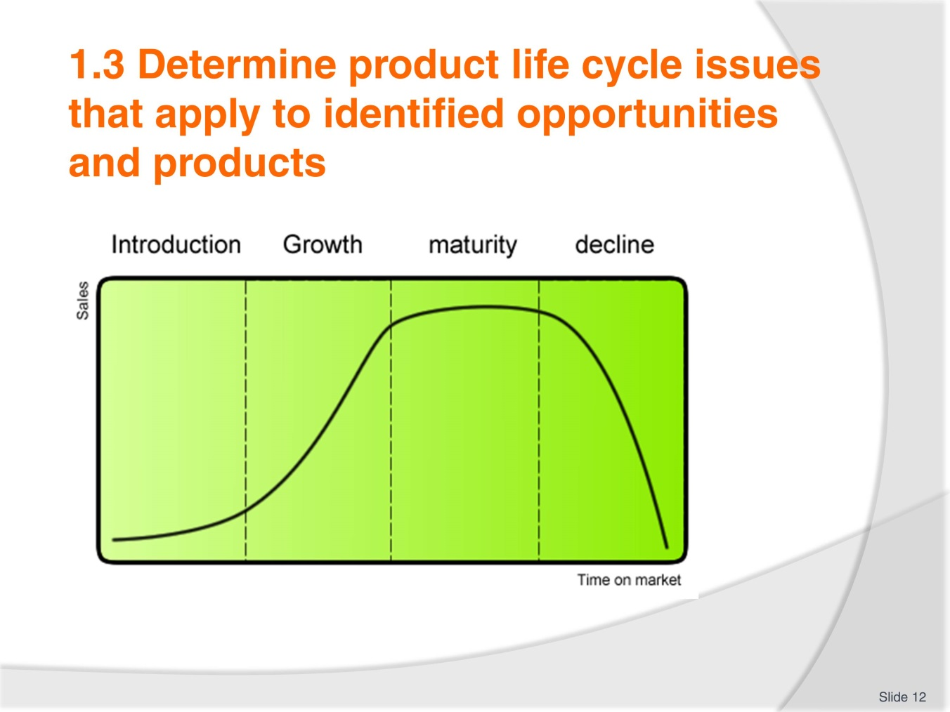
Slide No | Trainer Notes
Trainer explains the graph relating to product life cycle.
The product life cycle theory outlines how a product or a service moves from its original beginning as an idea, through development and implementation, to potential decline. The stage at which a product or service is at within the product life cycle can impact on what strategies are required to positively influence the product or service which could lead to reinvesting in the product or even ceasing delivery or offering of it.

Slide
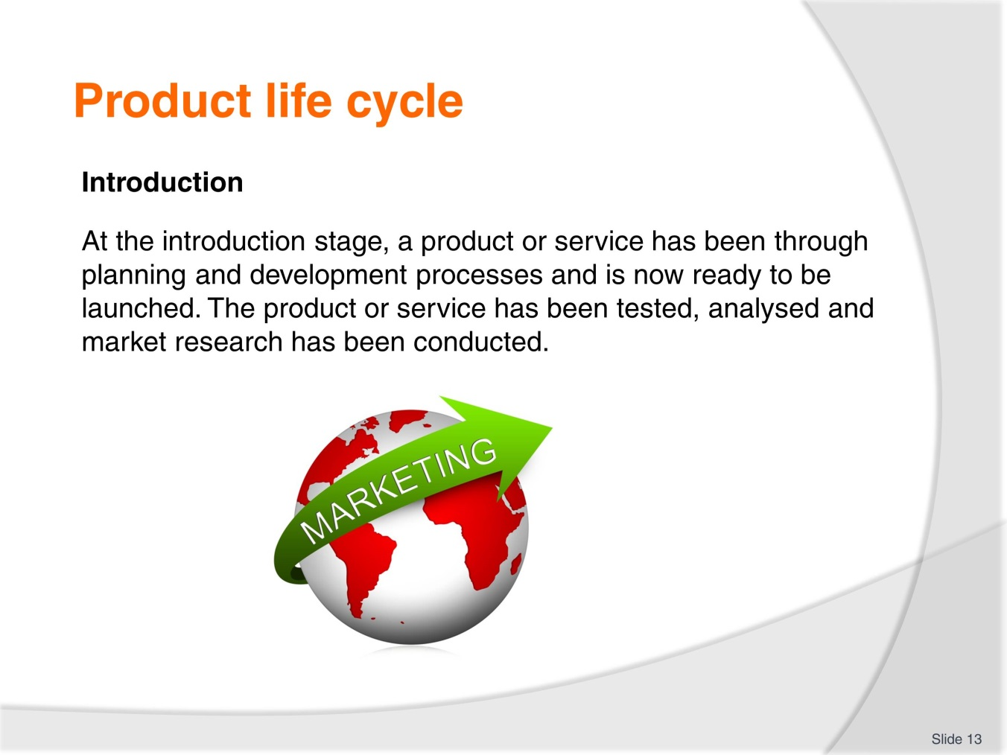
Slide No | Trainer Notes
 | Trainer goes through the slide with trainees. As can be seen in the graph in the previous slide, the initial introduction phase may not result in significant sales as the product or service needs to become known by the market.

Slide
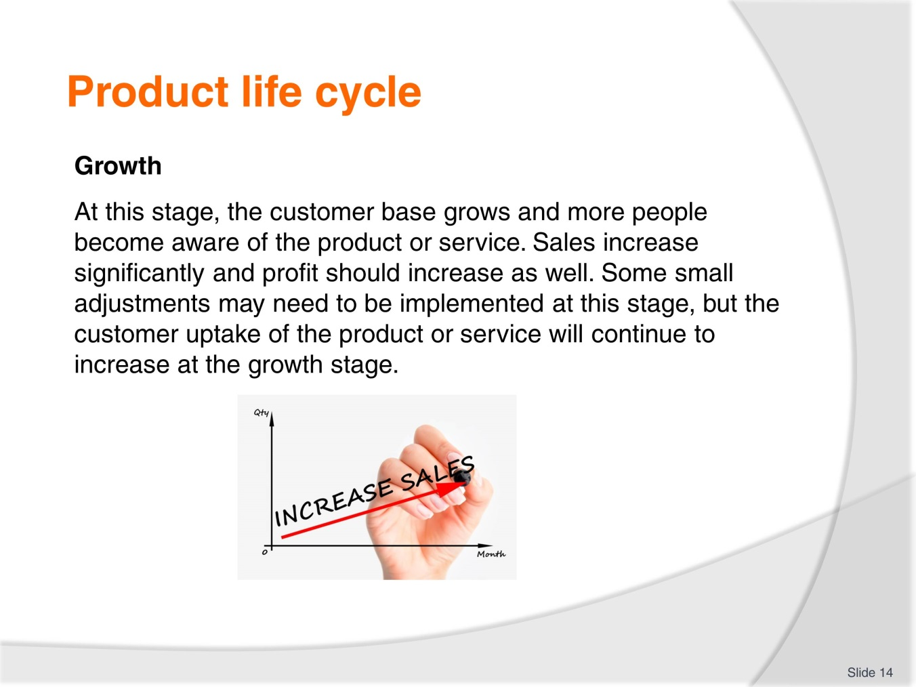
Slide No | Trainer Notes
 | Trainer introduces slide and discusses the growth stage. Trainer explains that the amount of growth and the duration of growth is not fixed and it may continue for a long time or it may be quick and steep but then plateau.

Slide
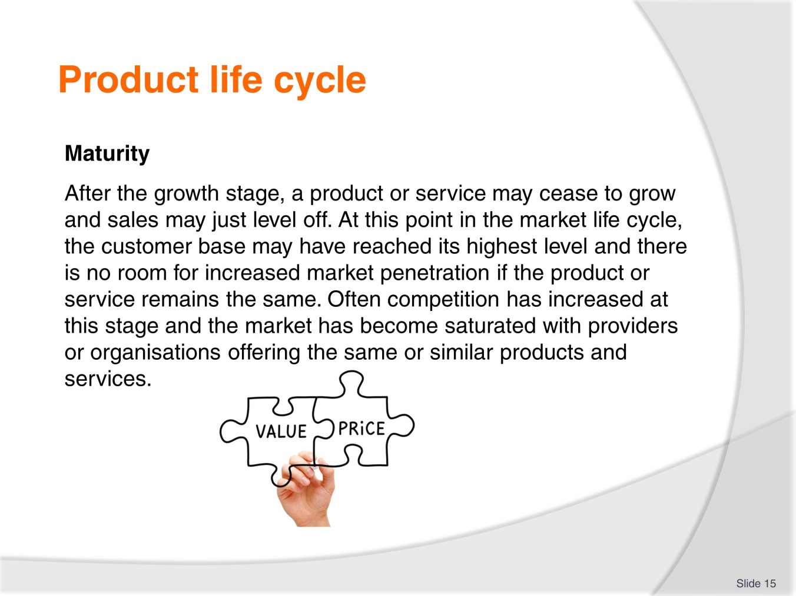
Slide No | Trainer Notes
Trainer goes through slide and presents the information below:
At the maturity stage, an organisation may look at ways to show customers how their product or service is unique from competitors, in an attempt to persuade customers to switch from a competitor to its product. There may also be a need to keep current customers so marketing campaigns may be developed to maintain the existing market share. Many products and services stay at the maturity stage and may not transition to the next stage.

Slide
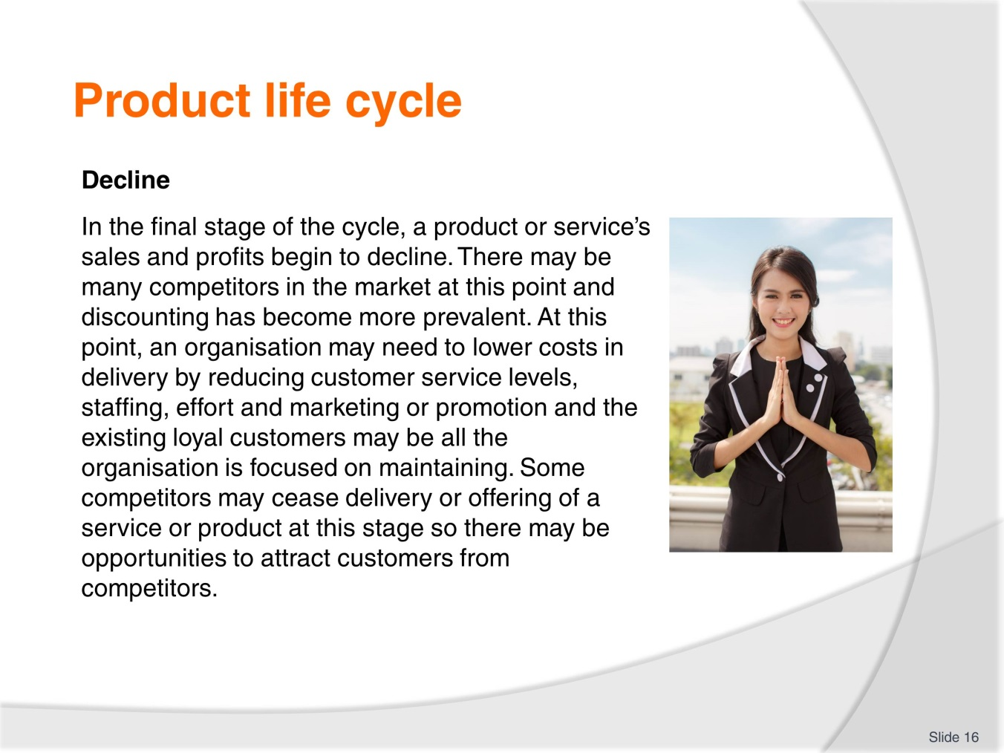
Slide No | Trainer Notes
 | Trainer goes through the information with trainees. Activity: trainer asks trainees to identify a product in their organization and determine where in the product life cycle it is. How do they know? What could be done to extend the life of the product or service?

Slide
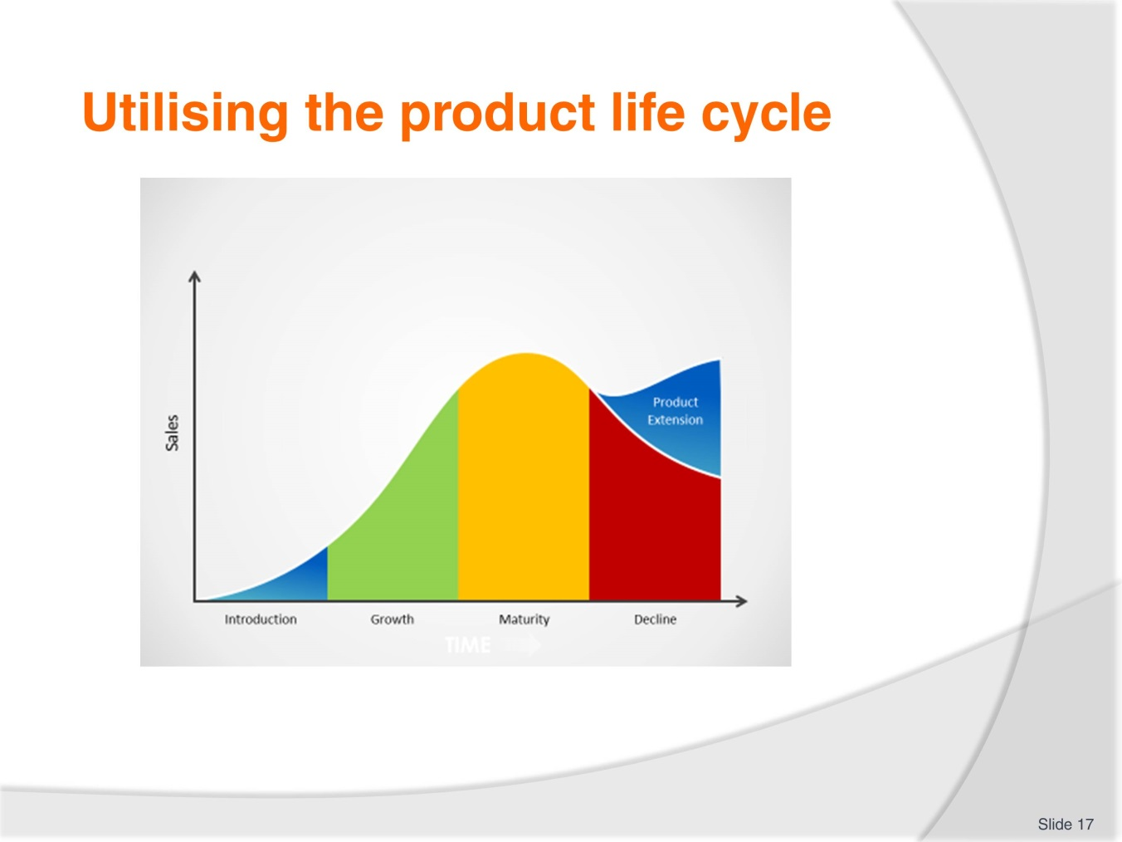
Slide No | Trainer Notes
The product life cycle as a tool
In order to take advantage of the product life cycle, it is necessary to identify where a product or service is at within the cycle and to examine competitor products and services within the four stages. It is possible to extend the product life cycle by increasing sales to current customers through encouraging them to buy more or to purchase more often.
It is possible to apply market penetration strategies to increase the amount of customers by attracting new customers to purchase the product or service. This may be difficult if there is growing competition and investment may be needed, but there may still be an opportunity to increase market share. For example, a hotel or resort may realise that there are local customers interested in using the facilities and the organisation may offer a special rate for local residents to use the gym, pool and offer discounts for food and beverage purchases.
Finding new uses for the existing product or service is also a potential opportunity to increase sales and extend the product life cycle. Different uses for a product or service may be discovered and promoted by the enterprise or it may be as a result of customer feedback.

Slide
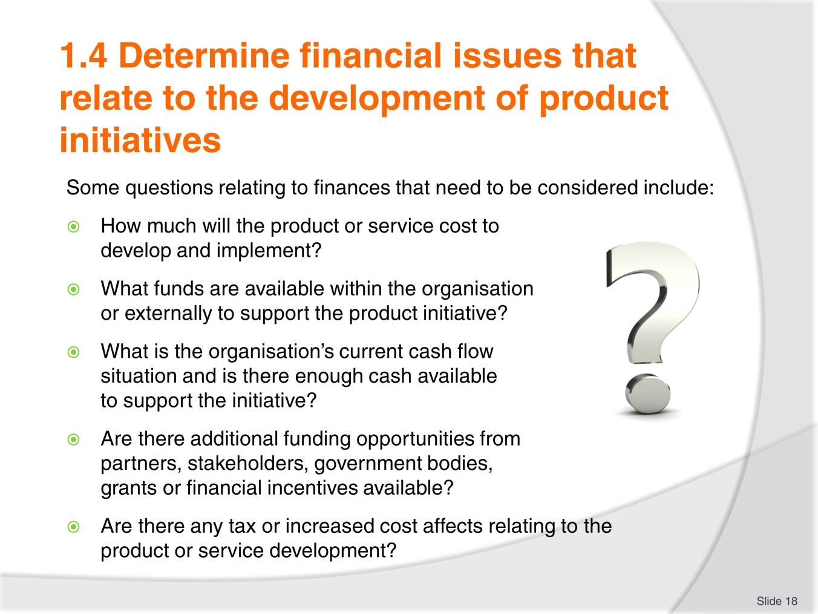
Slide No | Trainer Notes
 | Trainer introduces financial issues and explains that there are many aspects that need to be considered when developing and introducing new products and services. One of the most important factors to consider is financial issues that may affect product or service development. It may be determined that there is an opportunity to develop a new product or service but if the required funding is not available introducing the new item may not be viable. It is critical to examine all of the financial issues that may impact on new product or service initiatives.

Slide
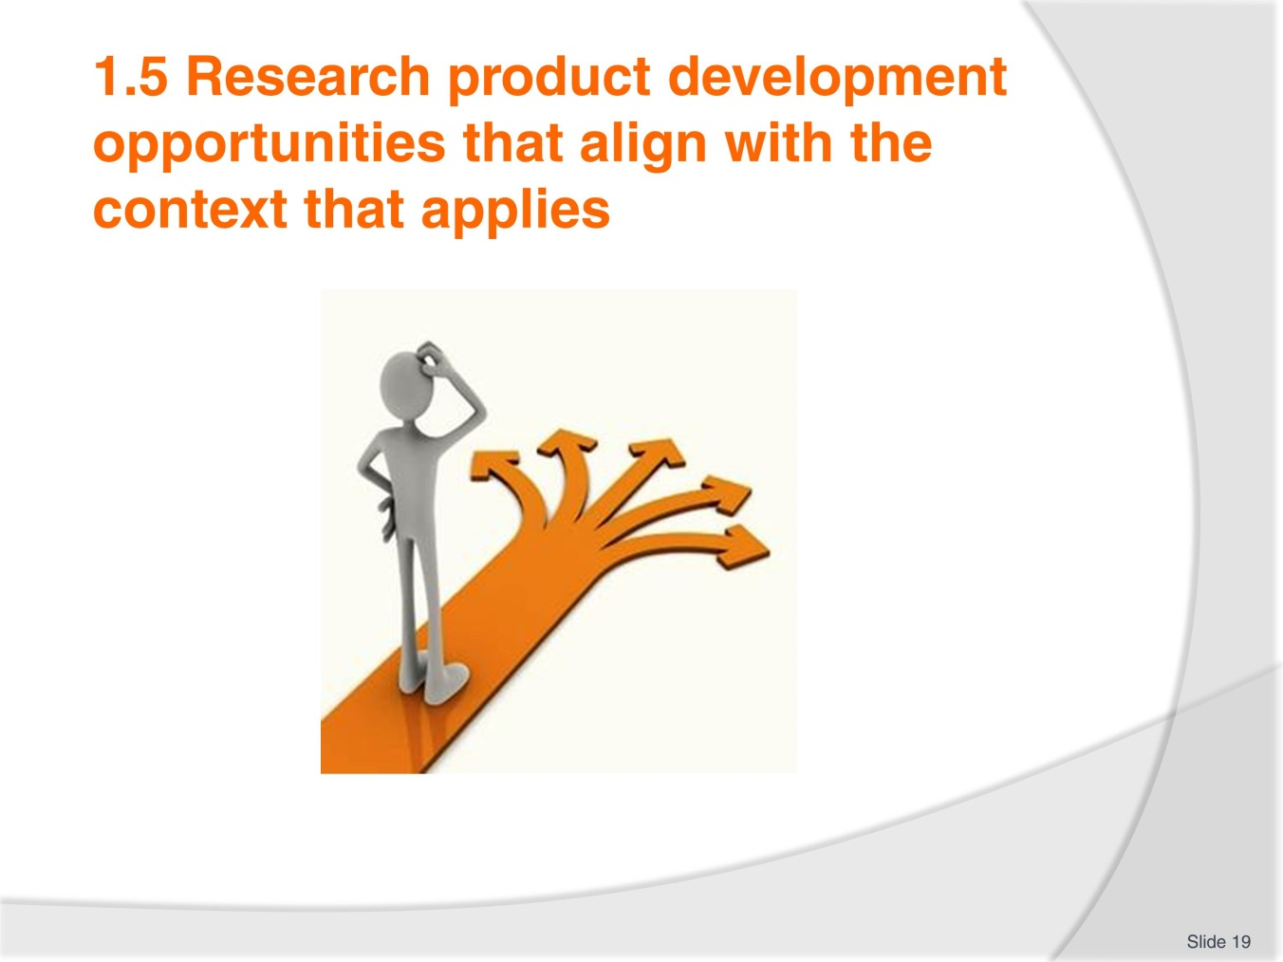
Slide No | Trainer Notes
 | Trainer explains the need to align business opportunities with the actual business context. Identifying business opportunities can be a challenging activity and it is important to utilise all available information and data before beginning a product development plan. Opportunities may be determined by a change in the external environment where an organisation sees a gap in the market place or a need that isn’t being met. Opportunities could also be identified by existing customers or by staff but it is necessary to determine what benefits new products may bring and whether they are feasible within the organisation’s context. The SWOT analysis will often provide a general idea of opportunities that could be targeted and further investigation is needed to decide if there is an opportunity to develop a new product or service.

Slide
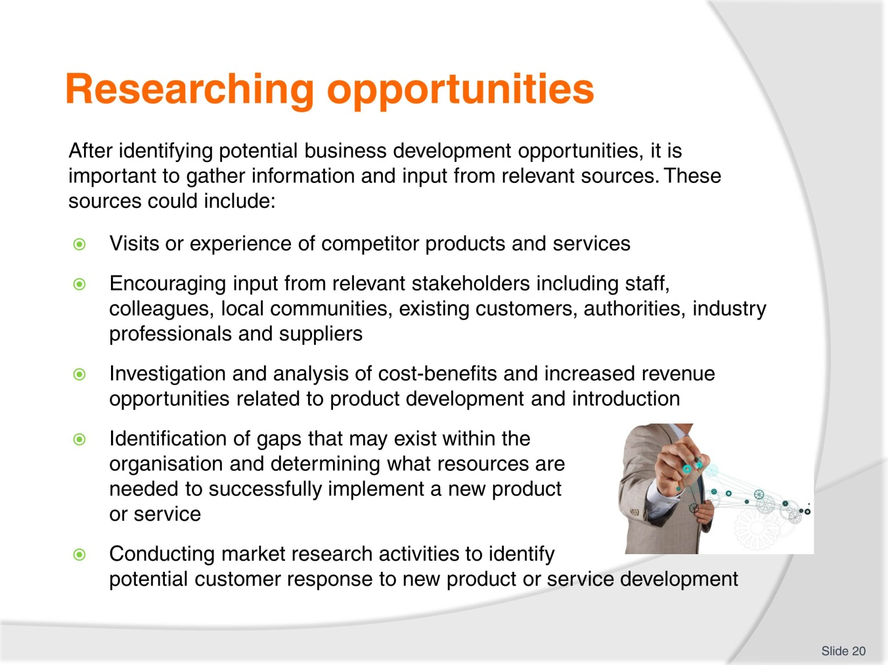
Slide No | Trainer Notes
 | Trainer explores the slide with trainees. The data collected from within the organization could provide an idea where opportunities are. For example, a staff member may have experienced a competitor’s product or service and identified it as a potential opportunity within their own organization.

Slide
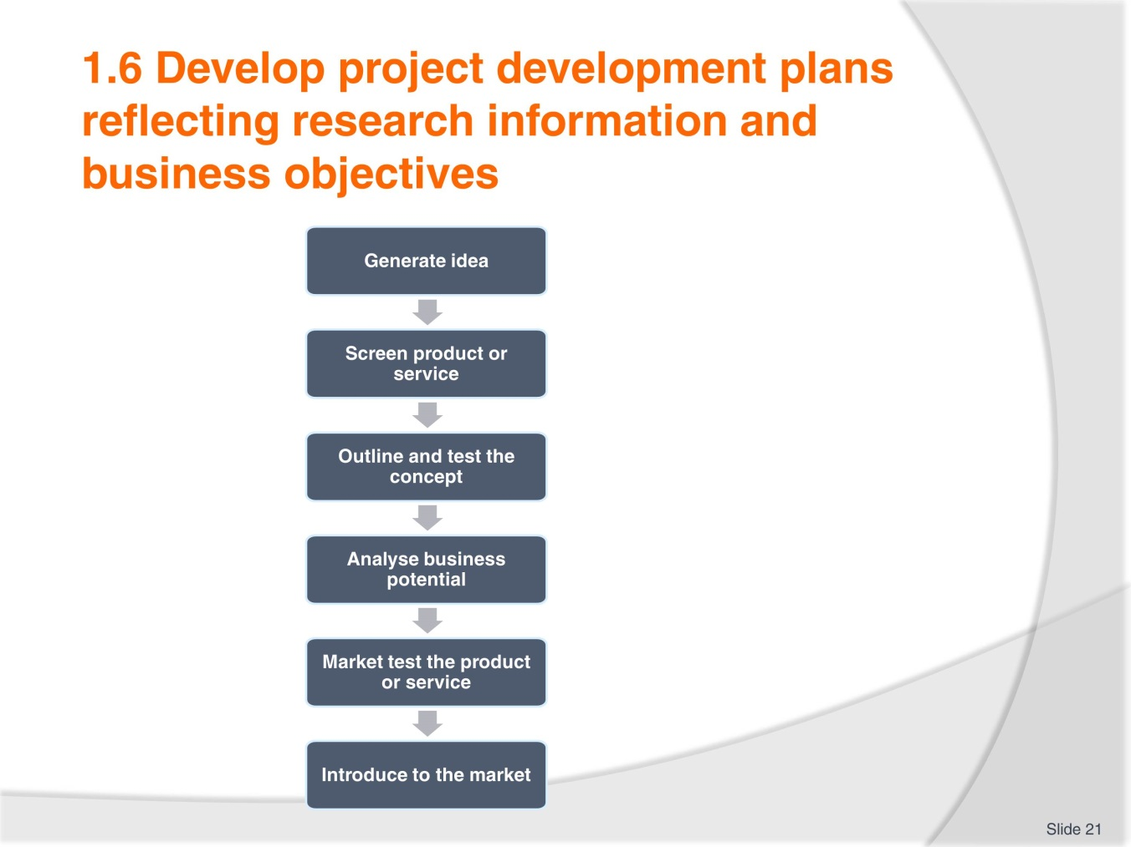
Slide No | Trainer Notes
 | Trainees read through the TM. Trainer utilizes information from the TM to elicit from trainees the need to generate good ideas for new products based upon evidence and perhaps a set of criteria as in the TM. Trainer goes through the phases in this slide and explains the activities at each stage.

Slide
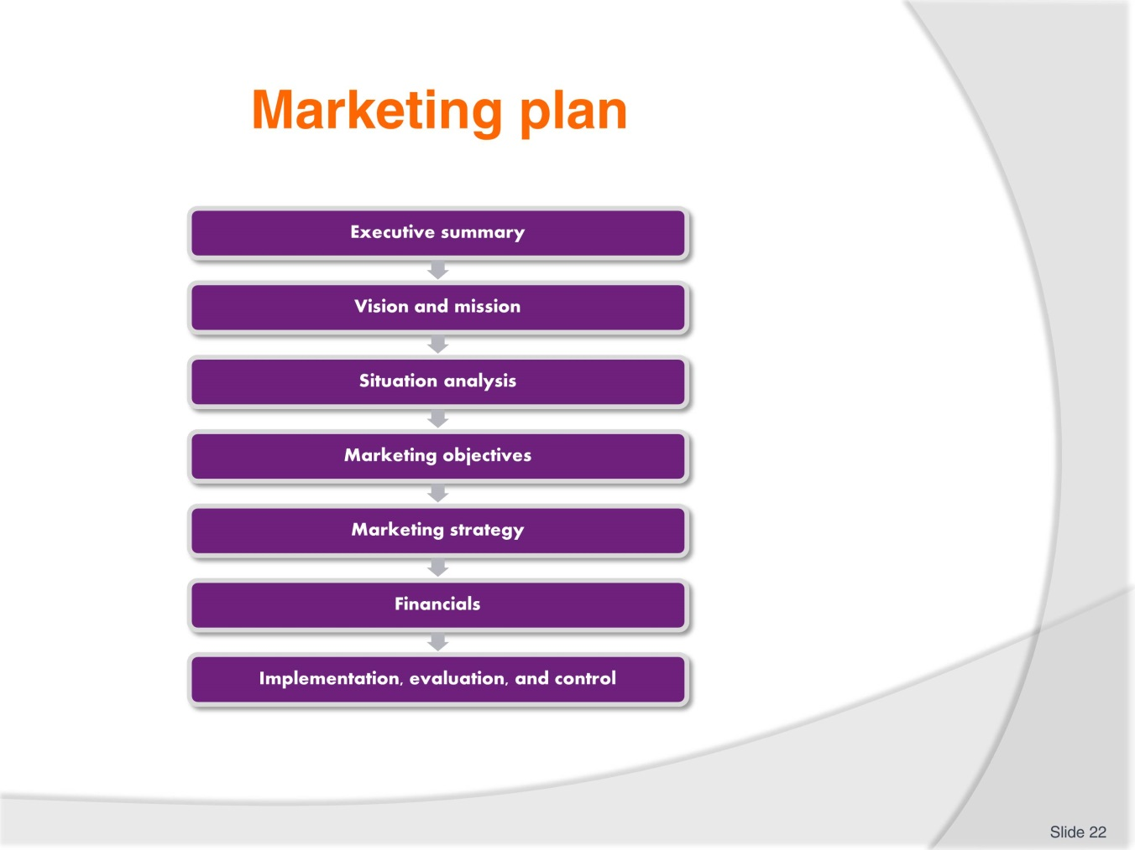
Slide No | Trainer Notes
 | Trainer explains that a marketing plan may also have to be developed as a part of the product development plan. There are many examples of marketing plans on the internet and it may be helpful to elicit trainees knowledge of marketing plans. Brainstorm with the class the different parts of the marketing plan and ask them if they have been involved with developing a marketing plan before.

Slide
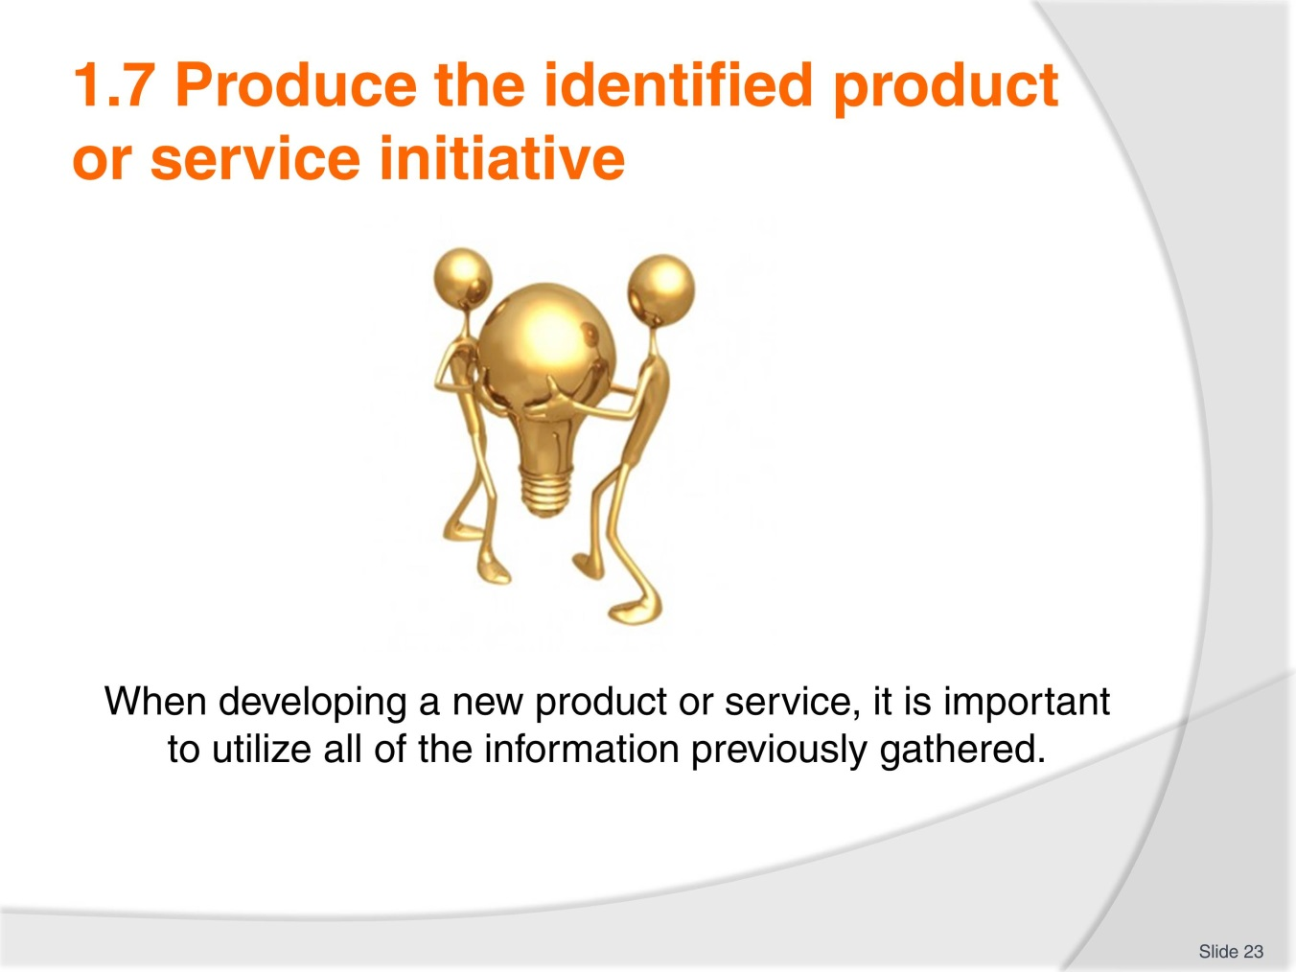
Slide No | Trainer Notes
 | Trainer explains the importance of drawing upon all previous information and data that has been gathered in order to produce a product or service that is effective. Ask students to brainstorm all of the information that might be relevant to producing a product or service. What type of information is needed? (Social, political, legal, environmental etc.)

Slide
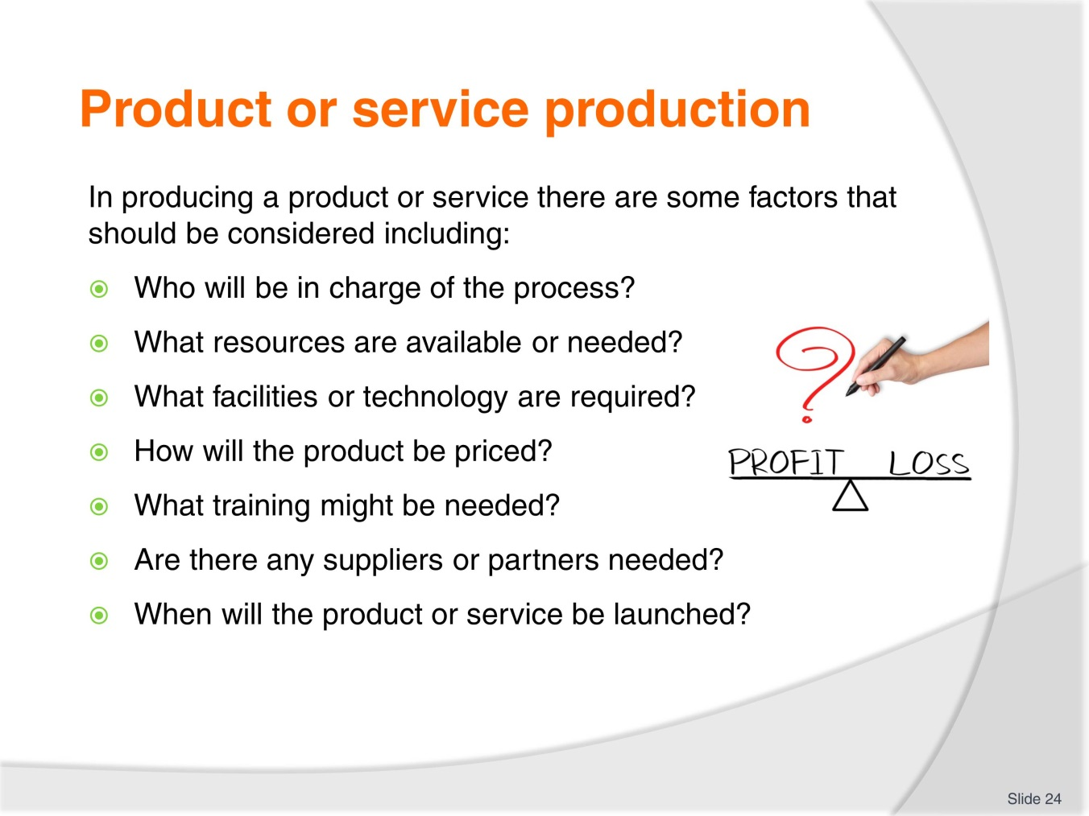
Slide No | Trainer Notes
Trainer goes through the slide and explains the content. Ask students to think of a product or service in their organization, and answer the questions in the slide for that product or service. Trainer elicits answers and extends responses.
Activity:
Think of a product or service within your organisation and outline all of the people involved in the delivery or offering of the product or service. What equipment, items, materials, and facilities are needed for the product to be accessed?

Slide
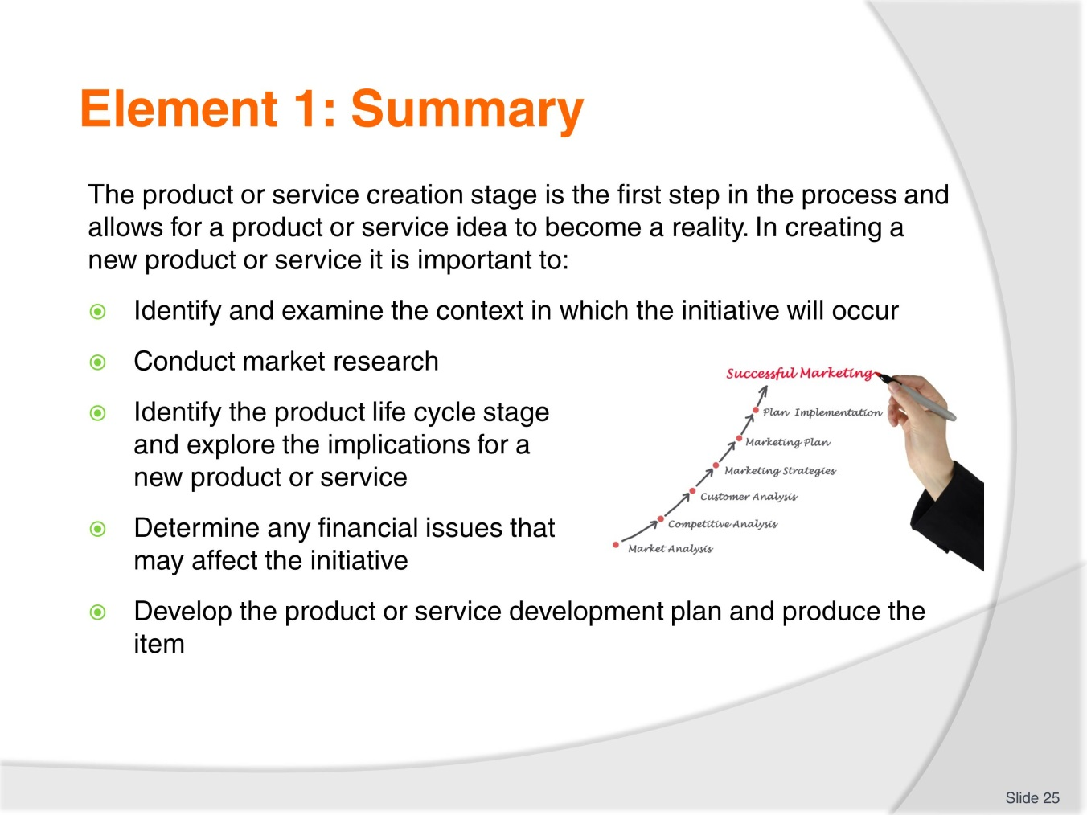
Slide No | Trainer Notes
 | Trainer goes through the summary and asks if there are any questions. Trainer should check if work projects have been completed

Slide
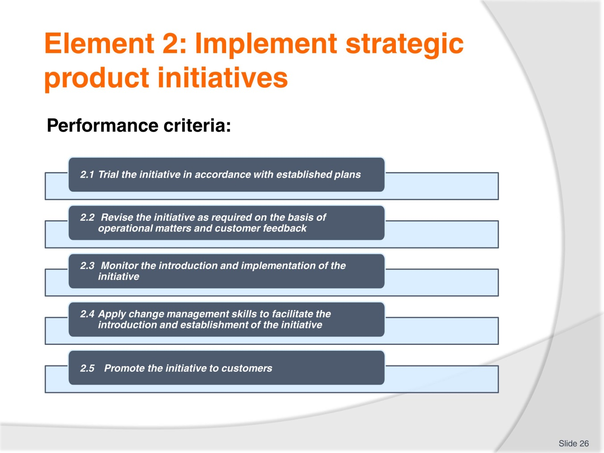
Slide No | Trainer Notes
 | Trainer introduces the element and goes through the performance criteria with the group. Trainer explains work projects for this element and due dates.

Slide
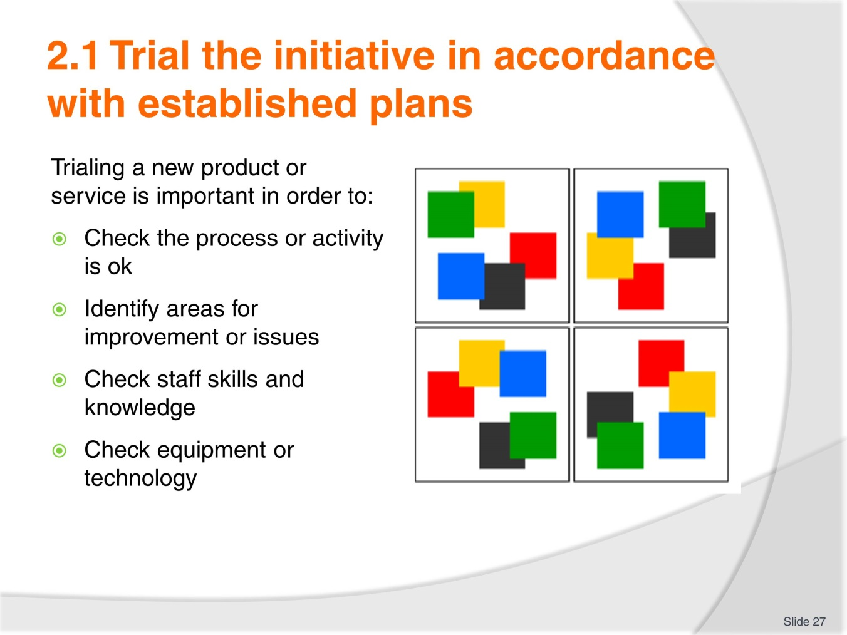
Slide No | Trainer Notes
 | Trainer goes through the information with trainees

Slide
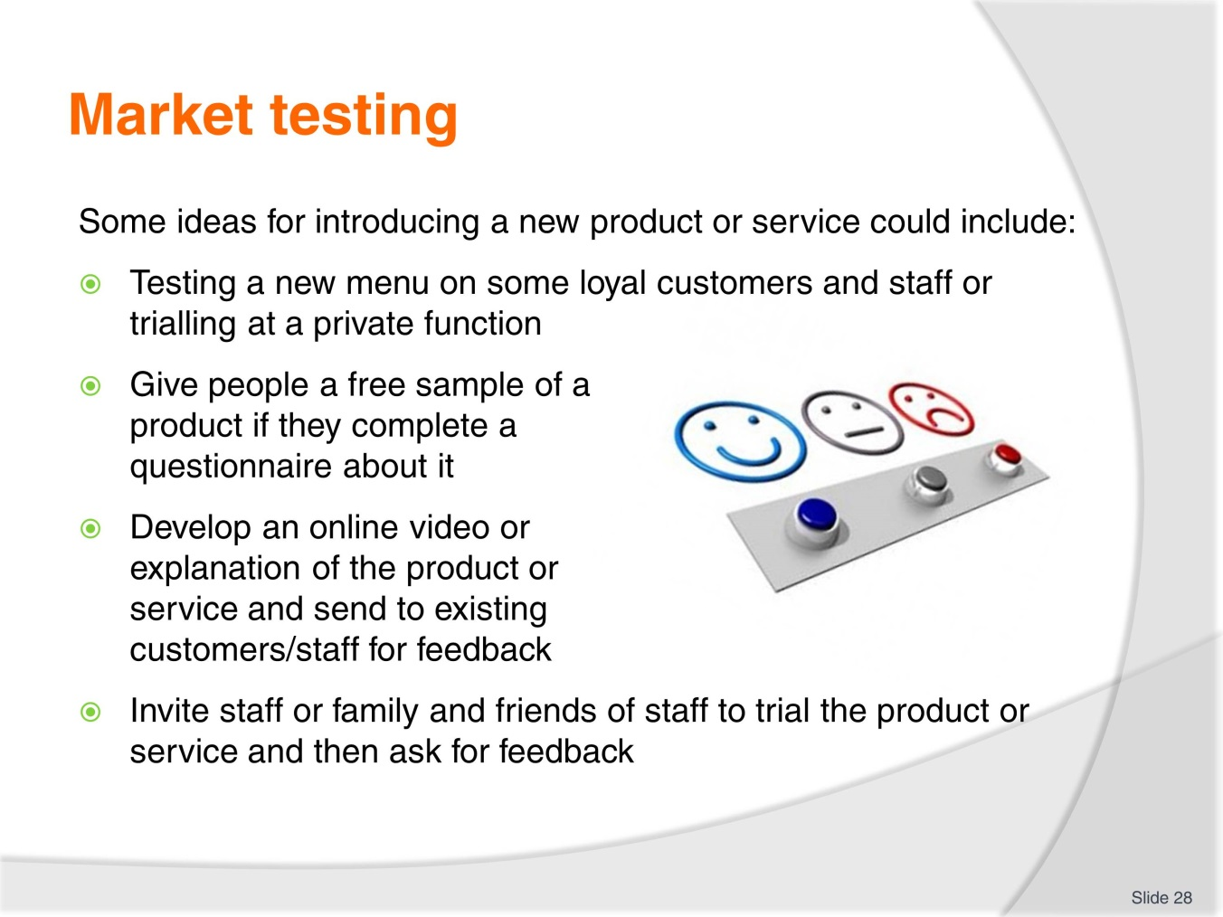
Slide No | Trainer Notes
 | Trainer elicits the importance of market testing. It is important to see if the product or service is easily delivered, used, purchased, maintained, and are there any issues or problems? Ask students to brainstorm some ways for introducing a new product or service. What have they done or experienced before? It could be for a product from a competitor or a different industry.

Slide
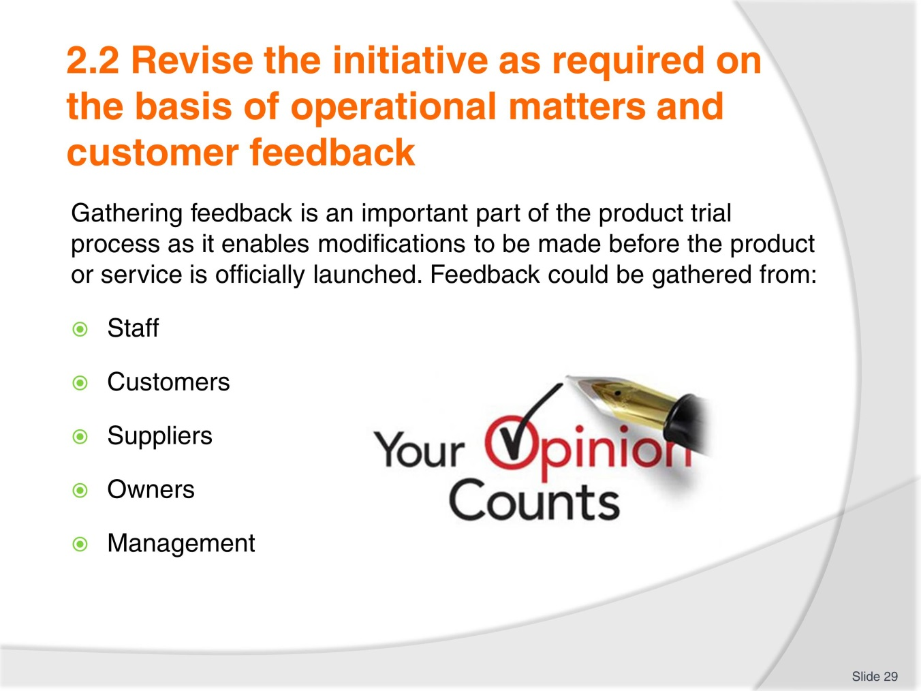
Slide No | Trainer Notes
 | Trainer explains the importance of gathering feedback. Feedback needs to come from a variety of sources and it needs to be analysed in order to determine possible revisions that may need to be made to the product or service. Trainer asks trainees how feedback is gathered within their organisations and asks students to give examples of changes that have been made to products or services due to feedback.

Slide
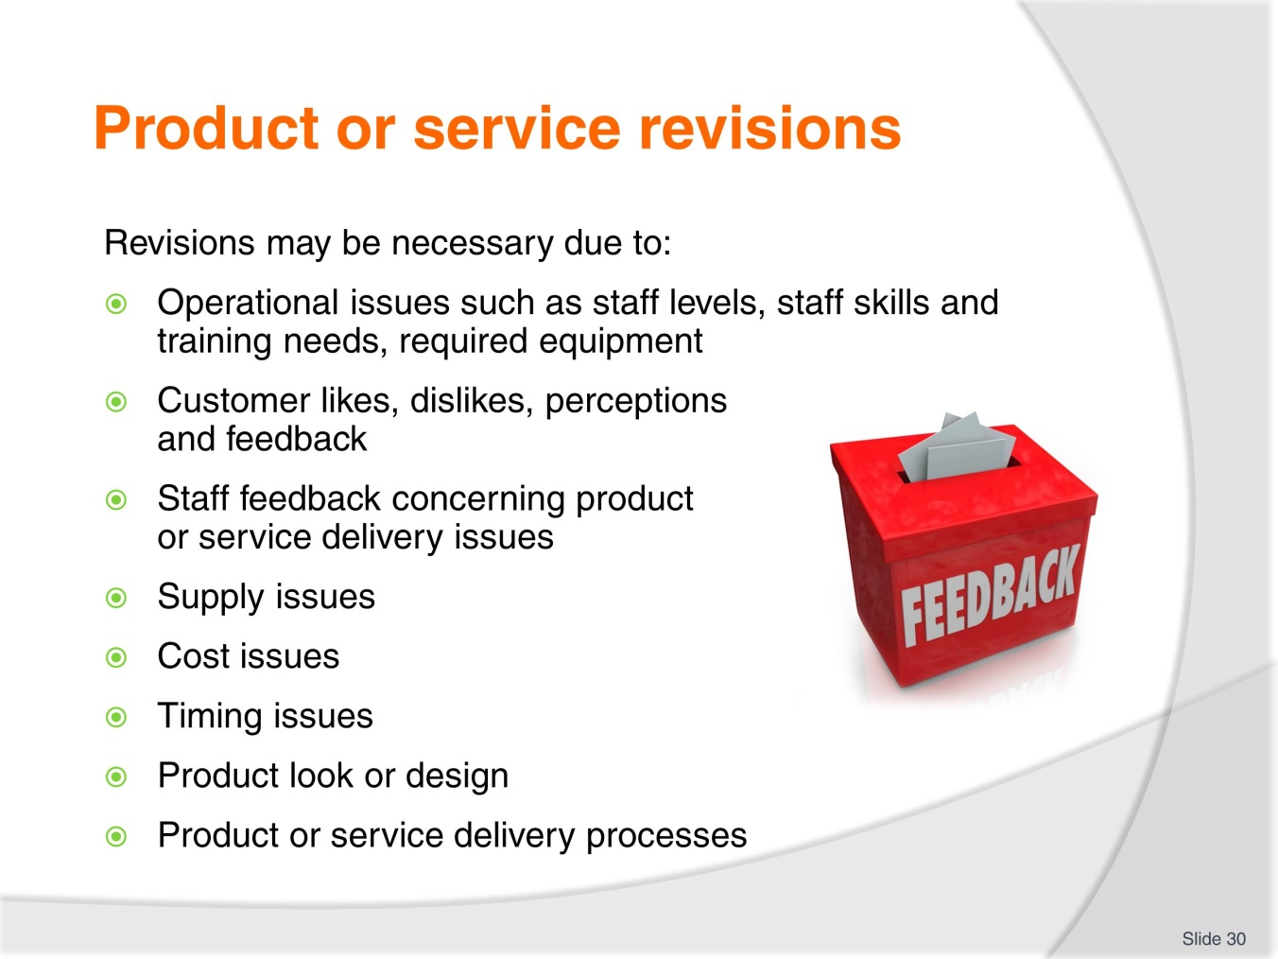
Slide No | Trainer Notes
 | Trainer elicits reasons why product or service initiatives may need to be altered. It is important to understand that no matter how well you plan, there is often something that has not been considered and trialling the product allows issues to be identified and rectified. Ask students to think of examples of the issues presented in the slide.

Slide
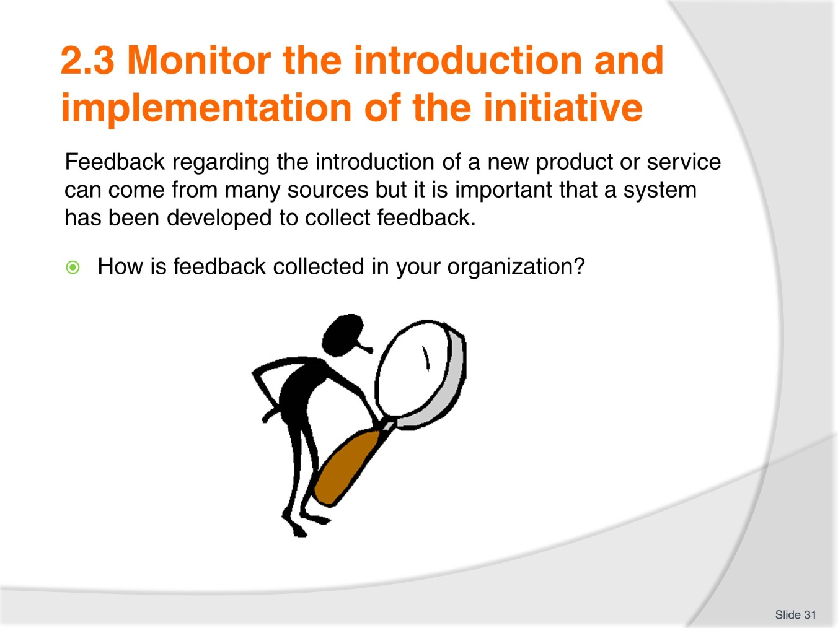
Slide No | Trainer Notes
 | Trainer introduces the slide and asks students to share feedback sources in their organization.

Slide
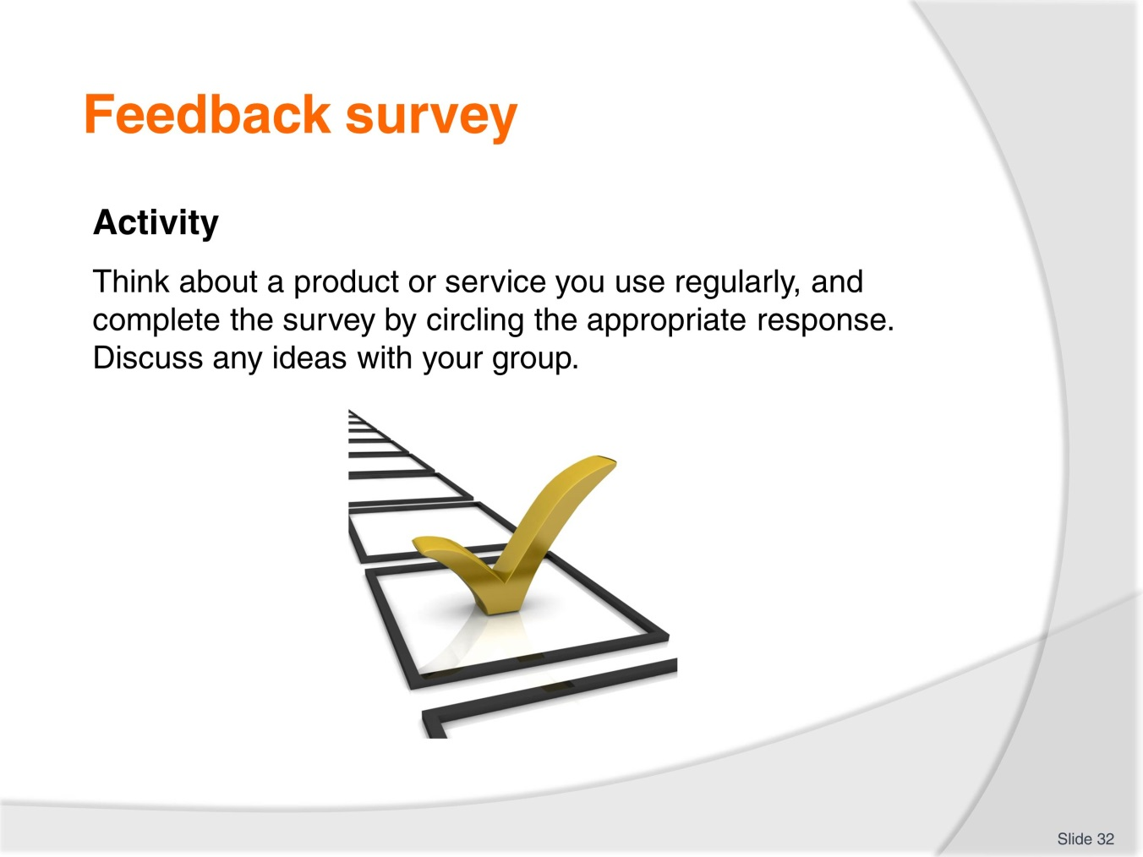
Slide No | Trainer Notes
 | Trainees read the information in their TMs and complete the survey activity. Trainer asks trainees to share their responses and experiences. How do they monitor product and services in their workplace? What changes were made to a product or service due to feedback?

Slide
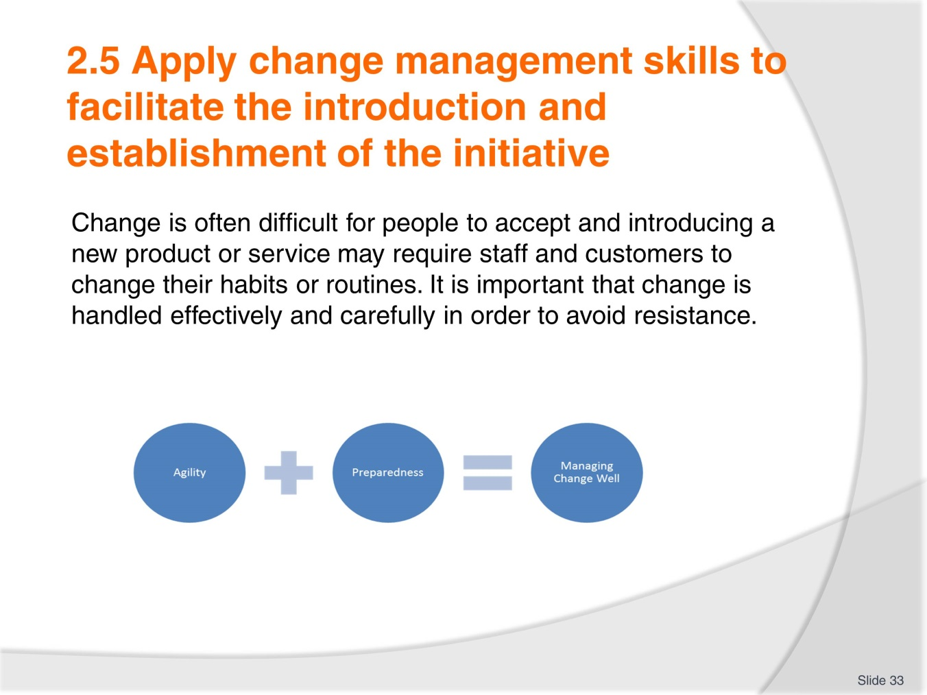
Slide No | Trainer Notes
 | Trainer explains the idea of change management and how change is often difficult to implement effectively. Trainer explains the picture in the slide which highlights agility or flexibility and preparedness as important to implementing effective change. People/staff/customers need to have a positive attitude to change and it is important for the organization to create this attitude. Trainer asks students to provide examples of poor change management skills that they have experienced. Trainer asks “What made the change fail?” Possible answers could be a lack of clear communication, rushing, not gathering enough feedback and responding to it.

Slide
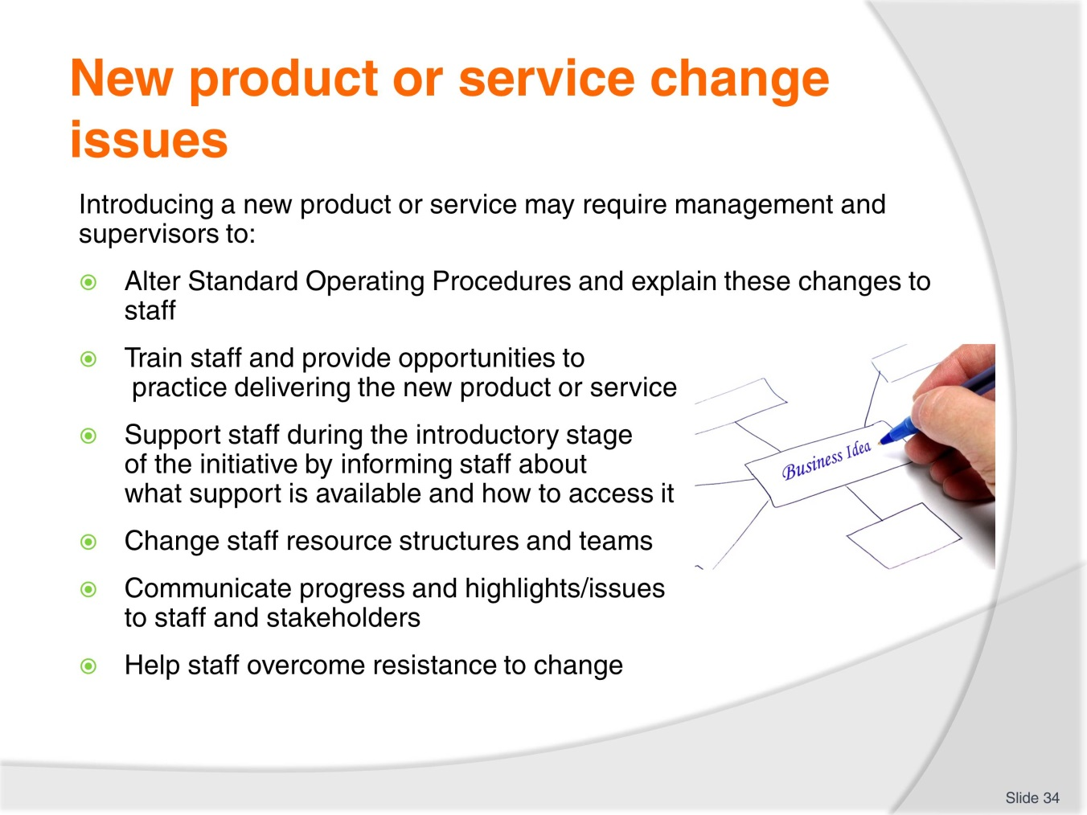
Slide No | Trainer Notes
 | Trainer goes through the examples with students and asks students to provide examples of any of the items in the slide.

Slide
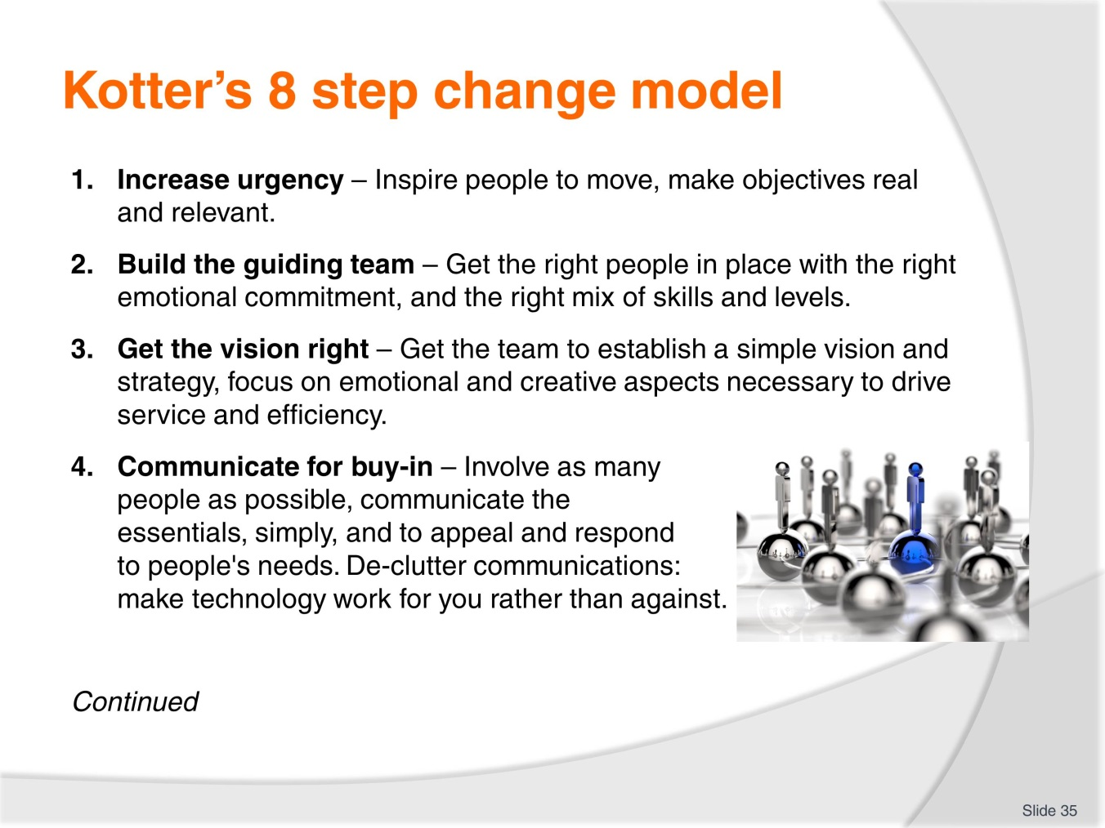
Slide No | Trainer Notes
 | Trainer goes through Kotter’s model for change using information from the TM. Trainer can use information from www.kotterinternational.com.

Slide
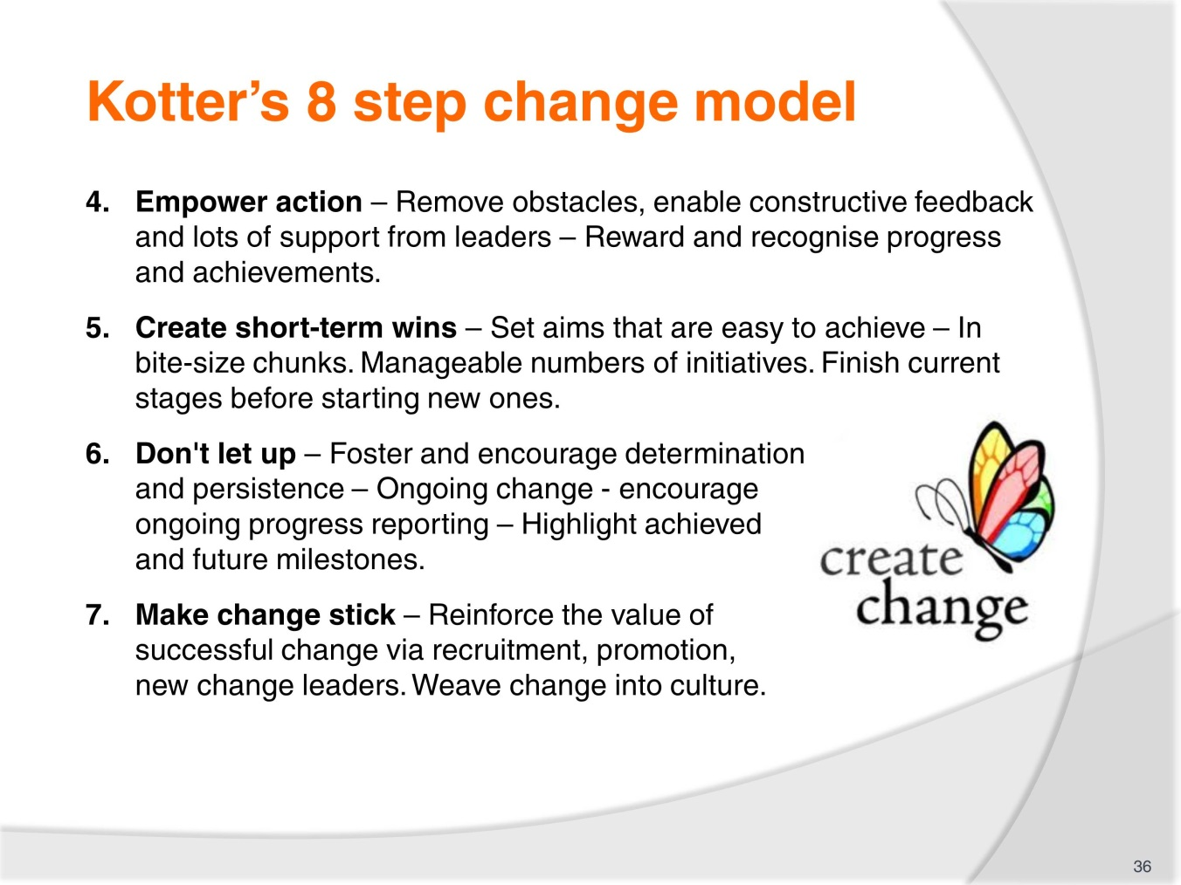
Slide No | Trainer Notes
 | Trainer goes through Kotter’s model for change using information from the TM. Trainer can use information from www.kotterinternational.com.

Slide
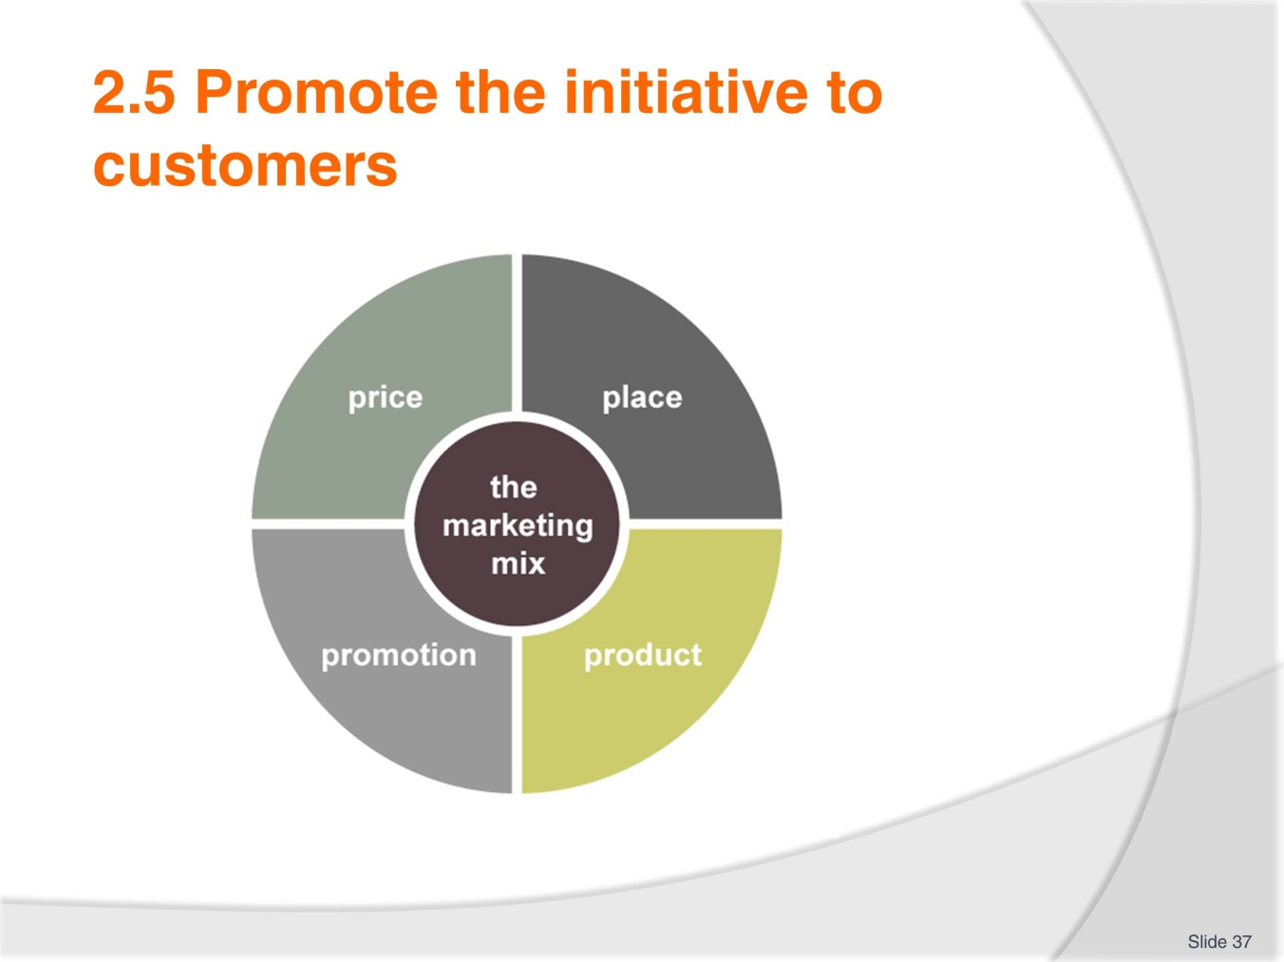
Slide No | Trainer Notes
Trainer explains the marketing mix and uses the TM to identify examples of the promotional mix.
It is important to ask:
- How can the product or service be promoted? Where and when can you inform customers of the new product or service?
- What advertising media will be used? Will it just be internally generated through brochures, verbal notification to customers, email, website, banners, social media or events?
- When is the best time to promote to your customers?
- How do your competitors promote their products and services, and are they effective strategies?
- What types of promotional activities have already proved successful within your organisation?
- What budget is available for promotional activities?

Slide

Slide No | Trainer Notes
Trainer explains the marketing mix and uses the TM to identify examples of the promotional mix.
It is important to ask:
- How can the product or service be promoted? Where and when can you inform customers of the new product or service?
- What advertising media will be used? Will it just be internally generated through brochures, verbal notification to customers, email, website, banners, social media or events?
- When is the best time to promote to your customers?
- How do your competitors promote their products and services, and are they effective strategies?
- What types of promotional activities have already proved successful within your organisation?
- What budget is available for promotional activities?

Slide
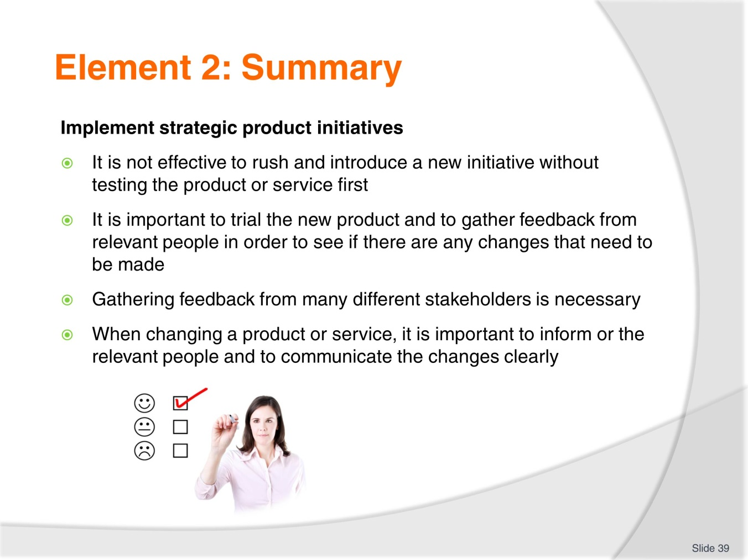
Slide No | Trainer Notes
 | Trainer summarises the element and reminds students of work projects and due dates.

Slide
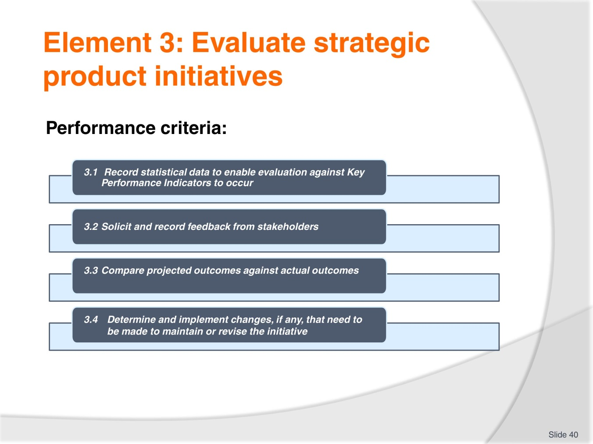
Slide No | Trainer Notes
 | Trainer introduces the element and goes through housekeeping with the trainees. Trainer informs students about work projects and due dates.

Slide
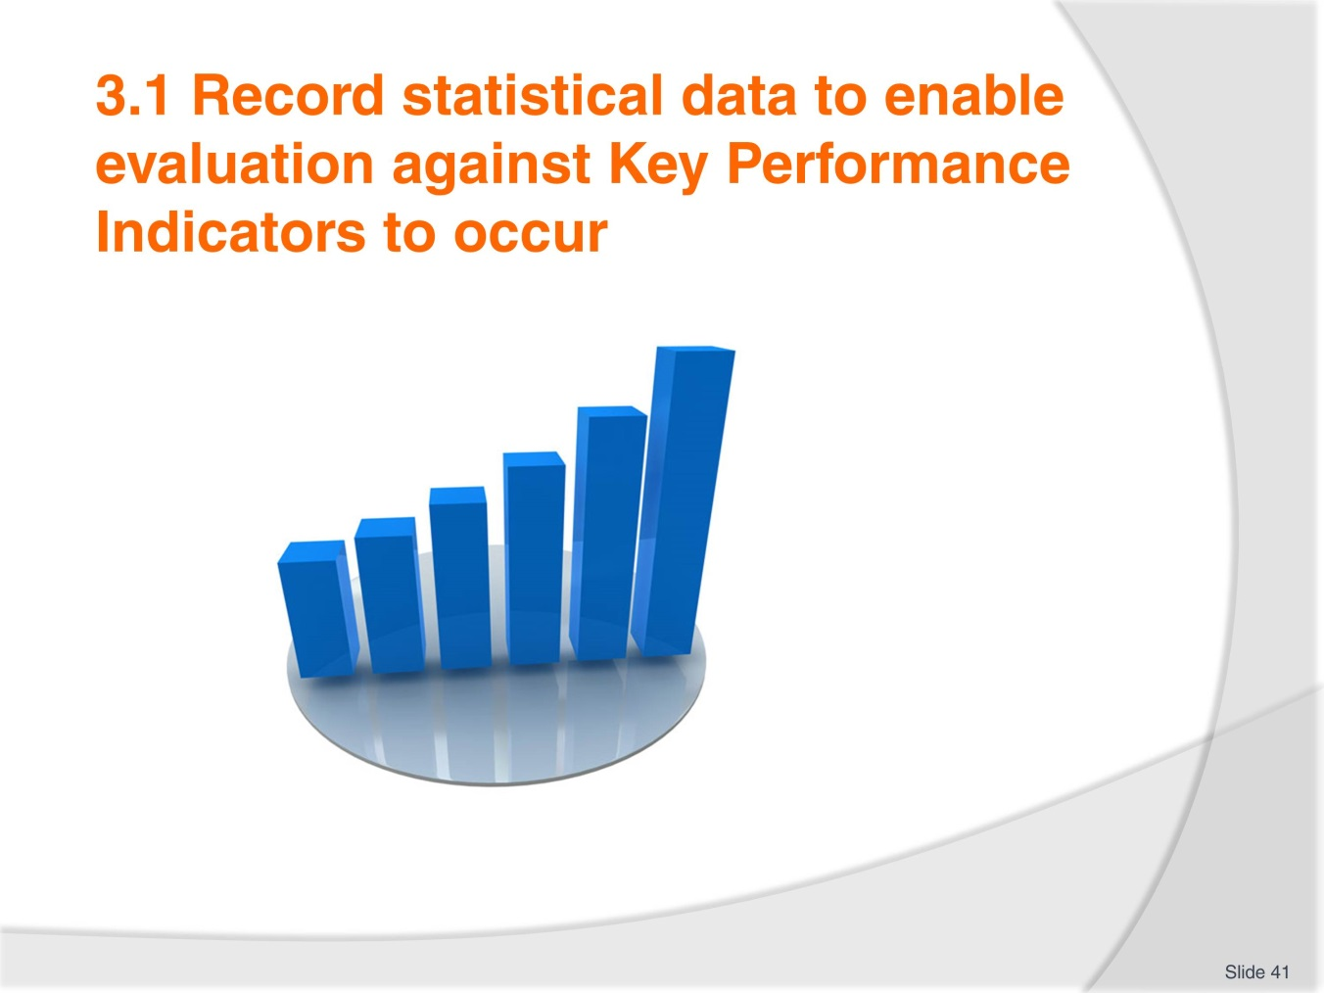
Slide No | Trainer Notes
 | Trainer explains the importance of collecting data and statistics that can help to determine the performance of a new product or service. It is necessary to compare statistics against KPIs to see if the product is reaching the goals that were outlined. Ask students to provide examples of statistics that may be useful for evaluating product or service performance: financial data, increases in customer numbers/sales, cost reductions.

Slide
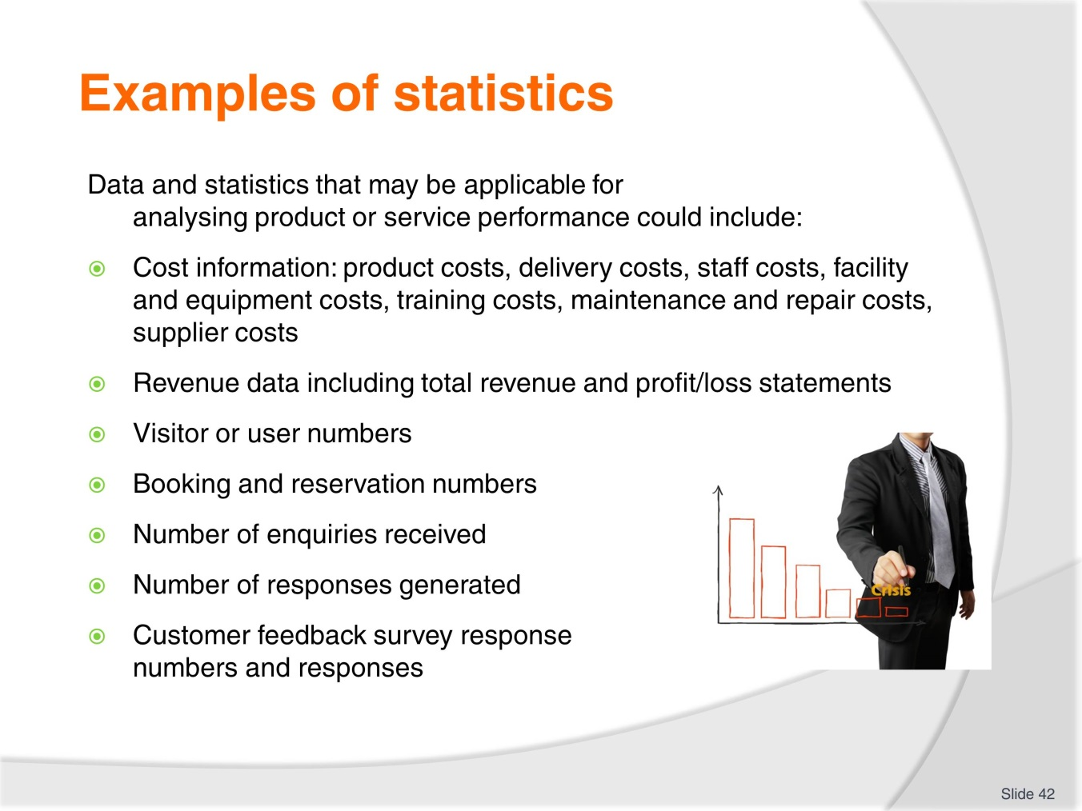
Slide No | Trainer Notes
 | Trainer goes through examples with trainees and elicits other examples from the group. What KPIs does their organisations set in regards to these examples?

Slide
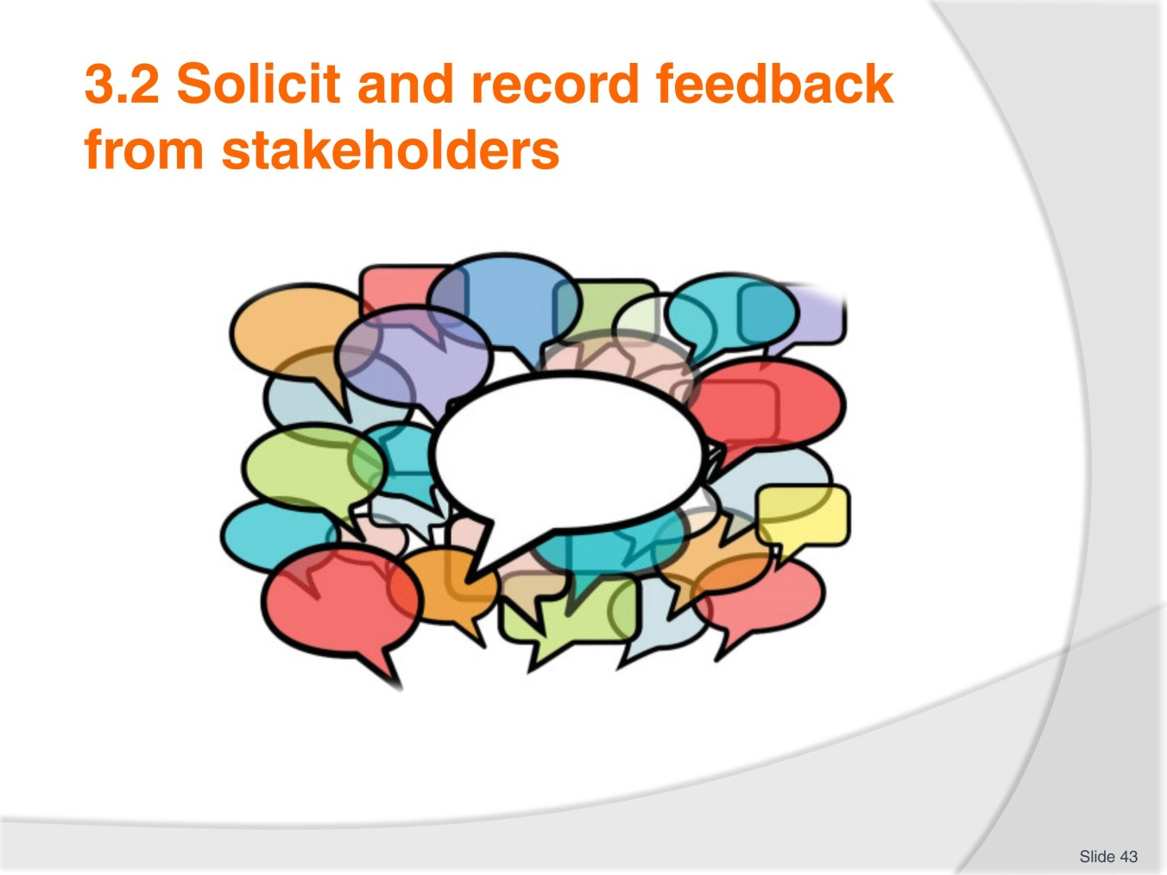
Slide No | Trainer Notes
 | Trainer explains the need for effective feedback gathering. Feedback needs to be collected from a variety of sources and should be collected regularly. It is important for an organisation to develop a culture where feedback is encouraged and actively sought rather than gathered randomly and inconsistently. Documenting feedback is also important in order to be able to monitor responses over time. Trainer explains that stakeholders could include many different people from managers, owners and suppliers, to staff and customers.

Slide
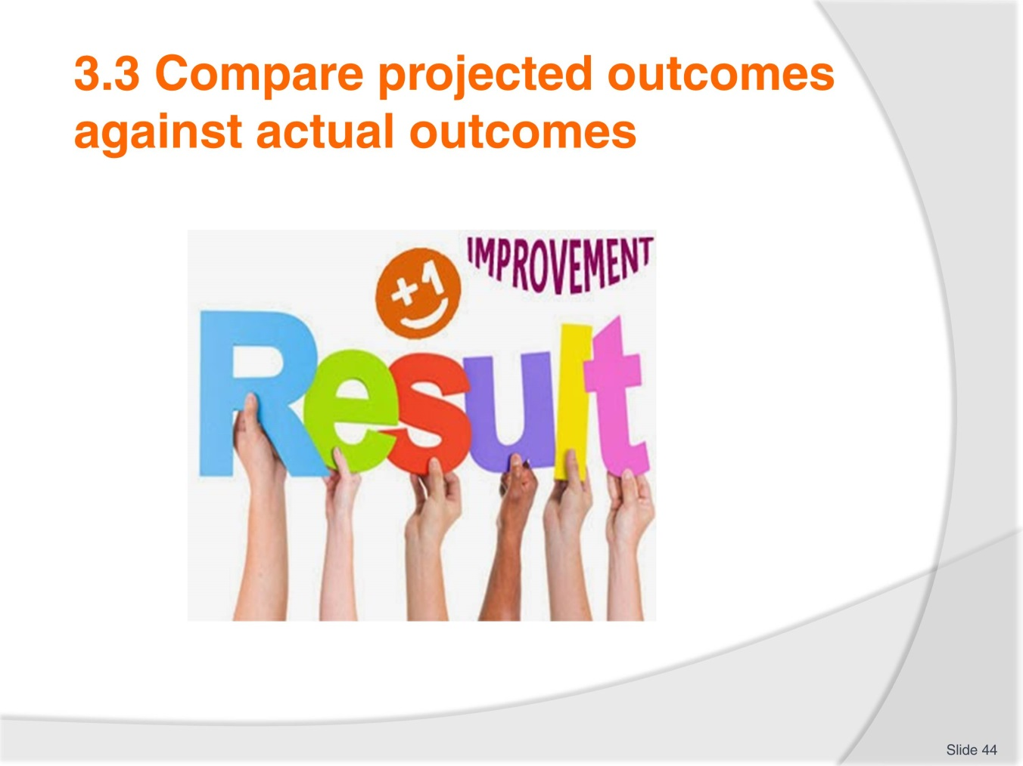
Slide No | Trainer Notes
 | Trainer elicits the need for evaluation of results or performance. If projected outcomes do not match actual outcomes then there needs to be an analysis of why the outcomes do not match. This may be due to a change in the business environment or context which differed from when the product plan was developed. The actual outcomes could be better or worse than predicted but either way there must be an examination of the performance.

Slide
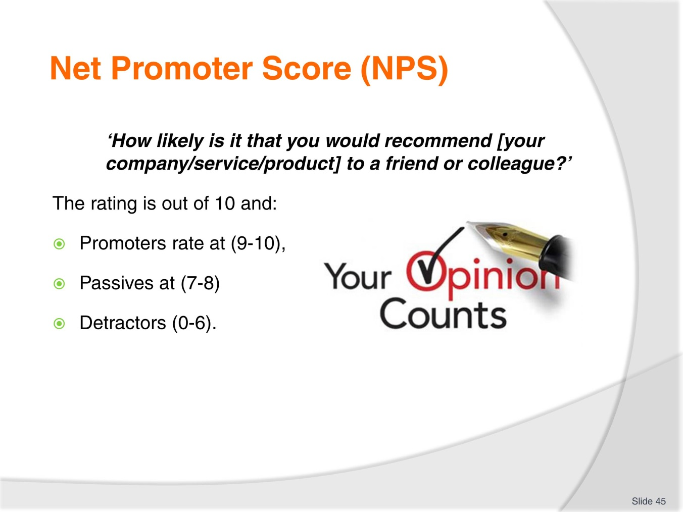
Slide No | Trainer Notes
 | Trainer explains what the Net Promoter Score is and asks if students have seen or if their organisations use this rating system. There is an example in the TM that could be used to elicit NPS.

Slide
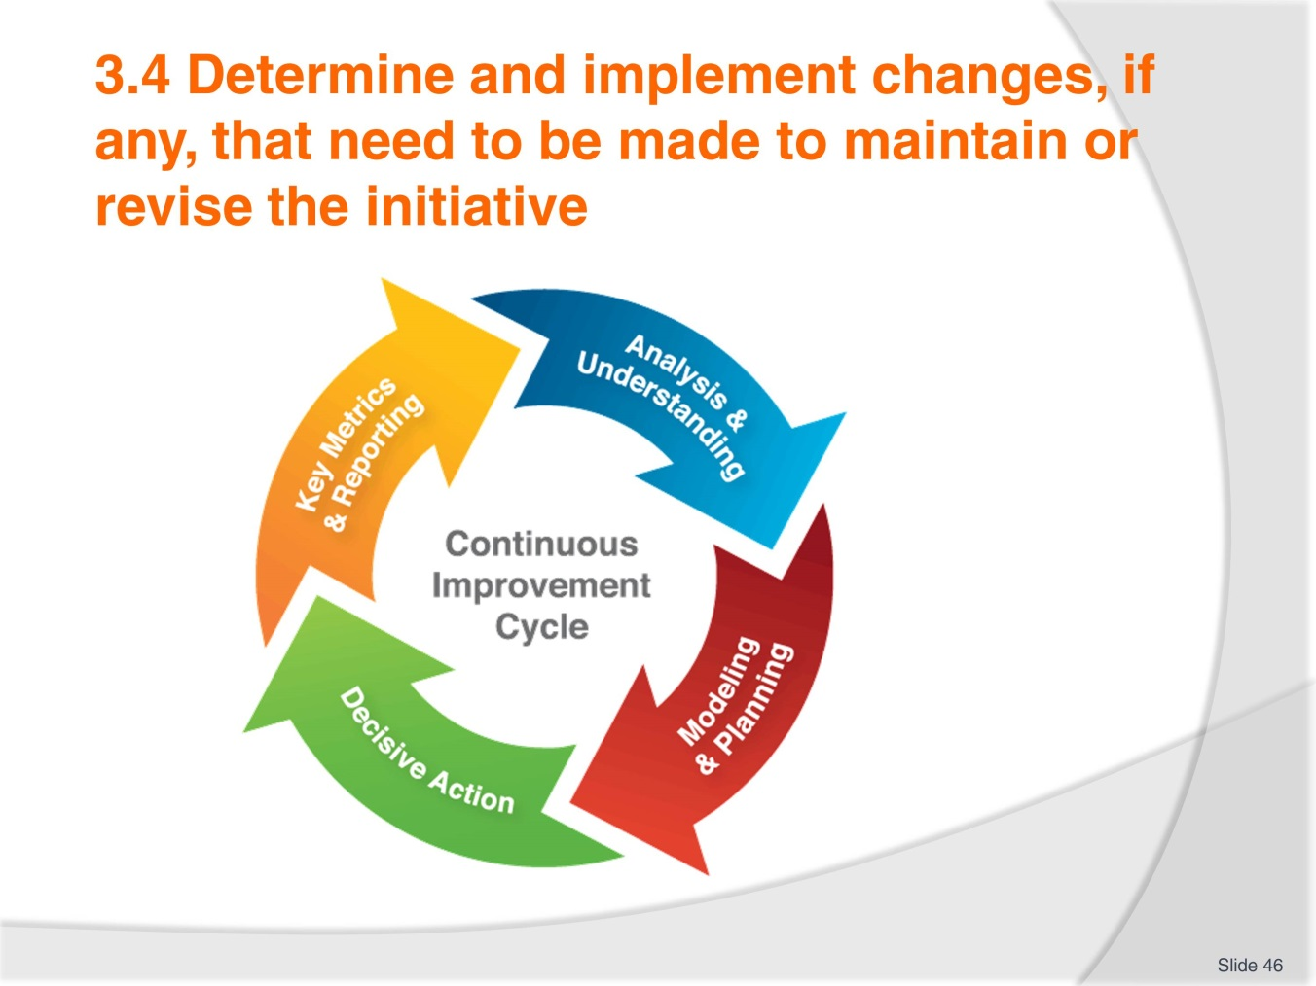
Slide No | Trainer Notes
Trainer explains what a continuous improvement cycle is and involves. Based upon previous units trainees should be able to explain what is needed to be done in order to maintain an effective product development process. If there are issues or successes identified it is necessary to respond to this information and alter the product or service to improve the initiative. Trainees read the TM and look at some areas that may require change. Trainees provide examples of changes that have been implemented within their work context regarding new product and service initiatives. Trainer asks what prompted the changes?
Trainer reminds students of work projects and due dates.

Recommended training equipment
- Business plan templates and examples
- Business strategies templates and examples
- Brochures
- Computer access
- Contingency plans
- Core business concept
- Corporate goals
- Customer feedback documentation
- Financial documents and budgets
- Industry statistics and trends
- Internet access
- Job descriptions for travel and tourism positions
- Key Performance Indicators
- Legal requirements for your country on a travel and tourism organisation
- Marketing and promotional plans and strategies
- Mission Statement
- Objectives
- Service audits
- SWOT Analysis template and examples
- Risk management policies
- Risk management plans
- Vision and values statement.

Instructions for Trainers for using
PowerPoint – Presenter View
Connect your laptop or computer to your projector equipment as per manufacturers’ instructions.
In PowerPoint, on the Slide Show menu, click Set up Show.
Under Multiple monitors, select the Show Presenter View check box.
In the Display slide show on list, click the monitor you want the slide show presentation to appear on.
Source: http://office.microsoft.com
Note:
In Presenter View:
You see your notes and have full control of the presentation
Your trainees only see the slide projected on to the screen
More Information
You can obtain more information on how to use PowerPoint from the Microsoft Online Help Centre, available at: http://office.microsoft.com/training/training.aspx?AssetID=RC011298761033
Note Regarding Currency of URLs
Please note that where references have been made to URLs in these training resources trainers will need to verify that the resource or document referred to is still current on the internet. Trainers should endeavour, where possible, to source similar alternative examples of material where it is found that either the website or the document in question is no longer available online.

Appendix – ASEAN acronyms
AADCP | ASEAN – Australia Development Cooperation Program
ACCSTP | ASEAN Common Competency Standards for Tourism Professionals
AEC | ASEAN Economic Community
AMS | ASEAN Member States
ASEAN | Association of Southeast Asian Nations
ASEC | ASEAN Secretariat
ATM | ASEAN Tourism Ministers
ATPMC | ASEAN Tourism Professionals Monitoring Committee
ATPRS | ASEAN Tourism Professional Registration System
ATFTMD | ASEAN Task Force on Tourism Manpower Development
CATC | Common ASEAN Tourism Curriculum
MRA | Mutual Recognition Arrangement
MTCO | Mekong Tourism Coordinating office
NTO | National Tourism Organisation
NTPB | National Tourism Professional Board
RQFSRS | Regional Qualifications Framework and Skills Recognition System
TPCB | Tourism Professional Certification Board





